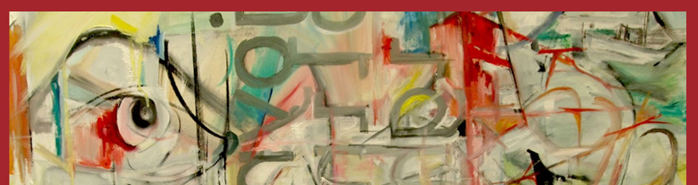 |  |  |  |  | ART DEPARTMENT SCHEME OF WORK for staff & students.
 |  |  |  |  | Course: A Level Fine Art
 |  |  |  |  | Year Group: Year 1
 |  |  |  |  | Teachers: Amanda Hall, Ian McAlister, Susie McAlister
EDUQAS Assessment Objectives for this course are:  AO1 Contextual Understanding 25%. Develop ideas through sustained and focused investigations informed by contextual and other sources, demonstrating analytical and critical understanding.  AO2 Creative Making 25%. Explore and select appropriate resources, media, materials, techniques and processes, reviewing and refining ideas as work develops.  AO3 Reflective Recording 25%. Record ideas, observations and insights relevant to intentions, reflecting critically on work and progress.  AO4 Personal Presentation 25%. Present a personal and meaningful response that realises intentions and, where appropriate, makes connections between visual and other elements. |  |  |  | Our Employer Representative Board (see FAQs) for the Visual Arts recommendations help us to understand how knowledge and skills developed within the subject supports your progression into the world of work and link strongly with the EDUQAS AOs, as demonstrated in the first few weeks of the curriculum below.  ERB 1: Research: Strong, advanced research skills with genuine curiosity for the industry itself.  ERB 2: Practical skills: Strong prior learning in basic art & design skills but a willingness to adapt & learn new industry specific skills.  ERB 3: Collaboration: The ability to openly collaborate , have good communication skills both verbally & digitally.
Week | Date | A Level Course Class work: | A Level Course Homework (5 hours): | Resources available/needed: | Pro Study:  Designed to introduce a breadth of contemporary artists, designers or practices which help define arts place in society & inclusive, diverse creativity. | Curriculum support & breadth:  This section highlights the other areas of the wider Arts curriculum: to include workshops, open studios, enrichment, planned trips, talks, competitions week by week during the year.
1 | Sept 9 | Intro to course.  Photos taken for etchings.  Dry-point etching from photographic portrait taken in low light with one light source. | 2 pages of visual research on contemporary artists Amy Judd and Dan Witz (his portraits with iPhone lighting) with personal annotations.2 pages: a photograph of own face but hiding part of it- using a hat, hoody, your hands, a scarf, obscured by a plant, object etc, taken on a phone is fine. Print-off and present the photo in sketchbook, then respond to it in any media eg. drawing, painting, collage, Photoshop etc . | See Share Point for Power Point introduction to course, Identity Project and use of Sketchbooks at A Level. | Christo – 5 mins http://www.youtube.com/watch?v=esiErDm62E4 | Workshops:Tues p2, Thurs 1.20pm lunch.  Open Studios: see timetable on doors for free rooms to work.  Lunchtimes: supervised open studios Mon-Fri.  Enrichment: 360-Y2 HE Portfolio Development Fridays, 2 sessions in D101 & D103.
2 | 16 | H/W critique.  Demmo of how to print using Intaglio soya based inks and press with H&S notes.  Print etching in 1 colour, then multiple inks.  Extension: take onto Photoshop or use watercolour & coloured pencils to hand colour one print. | 2 pages of research on the artists Christo And Jean Claude and Alison Watt. 2 page response: must be from real life, any media, photos can be included. | See Share Point for document of How to Scan and colour etchings in Photoshop. | Florian Nicholle: Florian Nicolle|illustration|neo http://www.youtube.com/watch?v=mO_WT3OZ-1Y | Workshops:Tues p2, Thurs 1.20pm lunch.  Open Studios: see timetable on doors for free rooms to work.  Lunchtimes: supervised open studios Mon-Fri.  Enrichment: 360- Y2 HE Portfolio Development Fridays, 2 sessions in D101 & D103.
3 | 23 | H/W critique.  Polybloc Printing block introduction:  Block preparation with biro using homework from Week 1. Add a background of an 'interesting place' - this could be a favorite real place; bedroom, coffee shop, beach, holiday.  Print polybloc with white ink on black sugar paper. Extension task: use collage, paint, pastels or Photoshop to add colour. | 2 page research on Tracey Emin's textiles hangings using her own words and Shirin Neschat. Double page response to their work, tell a secret, any media. | See Share Point: Watch video of Susie explaining how to make a good polybloc printing plate:  https://web.microsoftstream.com/video/e74f34f4-c222-400b-be0c-13dc5812e066 | Dan Mountford: Realisation de Dan Mountford, 36 sec.http://www.youtube.com/watch?v=JJViocM3NnQ | Workshops:Tues p2, Thurs 1.20pm lunch.  Open Studios: see timetable on doors for free rooms to work.  Lunchtimes: supervised open studios Mon-Fri.  Enrichment:360 Y2 HE Portfolio Development Fridays, 2 sessions in D101 & D103.
4 | 30 | H/W critique.  Complete both etchings and polybloc prints & extension tasks. | Take 10 photos ( a phone will do for this), of YOUR PERFECT VIEW and present beautifully in book. | See Share Point for examples of student lino prints to inspire homework photos. | Tate Shots: Tracey Emin My Bed | Workshops:Tues p2, Thurs 1.20pm lunch.  Open Studios: see timetable on doors for free rooms to work.  Lunchtimes: supervised open studios Mon-Fri.  Enrichment: 360 Y2 HE Portfolio Development Fridays, 2 sessions in D101 & D103.
5 | Oct 7 | H/W critique.  Intro of reductive lino process & examples.  Demmo of photoshop process with handout for reference.  Use photoshop to simplify your photo choice for reductive lino cutting.  Demmo of cutting lino safely.  Cut & print first colour as demonstrated by teacher, paying attention to Health & Safety use of the lino tools. | 2 double pages of visual artists research on lino artists:  Angie Lewin, Teresa Winchester, Jonny Hannah. | See Share Point for Handout sheet to lead developing photos into a 2 colour lino on Photoshop. | Sherin Neschat: Beginning of the Cold Season. 5 mins. http://youtu.be/Zh4oEfiNuSU | Workshops:Tues p2, Thurs 1.20pm lunch.  Open Studios: see timetable on doors for free rooms to work.  Lunchtimes: supervised open studios Mon-Fri.  Enrichment: Drop-in: Fridays 12.15pm: Y1&2 Careers advice, portfolios, interview practice.  Trip: Leonardslee Gardens with Surrey Sculpture Society, see Share Point for details.
6 | 14 | H/W critique.  Print first colour/second in reduction lino. | Take a series of 6 photographic self-portraits both face only and whole body using the list on share Point as a guide. | See share Point for guide for photos and examples on display in D101. | Gillian Wearing: Dancing in Peckham. http://www.youtube.com/watch?v=60o_GUNxG_M | Workshops:Tues p2, Thurs 1.20pm lunch.  Open Studios: see timetable on doors for free rooms to work.  Lunchtimes: supervised open studios Mon-Fri.  Enrichment: Drop-in: Fridays 12.15pm: Y1&2 Careers advice, portfolios, interview practice.
7 | 21 | H/W critique.  Complete last colour of reduction lino print. | 2 Double pages of research on the artists Anthony Green(British), Hope Gangloff (New Yorker) and Ikenaga Yasunari(Japanese | See Share Point for ideas about what annotations to add to visual research of artists work. | Tate Shots: Paula Rego | Open Studios: see timetable on doors for free rooms to work.  Lunchtimes: supervised open studios Mon-Fri.  Enrichment: Drop-in: Fridays 12.15pm: Y1&2 Careers advice, portfolios, interview practice  Competition: Design mural for new Common Room, see Share Point for details.
 |  | HALF TERM
8 | Nov 4 | 4 INSET  Composition intro to canvas on Photoshop and task. | To complete the composition drawing task. Then create a single page moodboard of painted portraits chosen from the internet and 1 page of research on the favorite portrait artist, annotation questions on share Point. | Power Point introduction to Composition, take notes in sketchbook on basic rules & explanations.  See Share Point for ‘How to use a Canvas Mask guide’ to help compose canvas on Photoshop.See Share Point for all set work with examples and Power Points. | Tate Shots: Quentin Blake. | Workshops:Tues p2, Thurs 1.20pm lunch.  Open Studios: see timetable on doors for free rooms to work.  Lunchtimes: supervised open studios Mon-Fri.  Enrichment: Drop-in: Fridays 12.15pm: Y1&2 Careers advice, portfolios, interview practice.
9 | 11 | Wed Open Evening  Thurs Open Evening  Friday no lessons.  Present reduction print in sketchbook, fully annotated and titled. | Use this time to make sure ALL your class and homeworks are presented beautifully in your book. You start the painting project next week. | See Share Point for all set work with examples and Power Points. | You Tube: Tate Shots: Bob and Roberta Smith | Workshops:Tues p2, Thurs 1.20pm lunch.  Open Studios: see timetable on doors for free rooms to work.  Lunchtimes: supervised open studios Mon-Fri.  Enrichment: Drop-in: Fridays 12.15pm: Y1&2 Careers advice, portfolios, interview practice.
10 | 18 | Complete the composition of the canvas and translate onto stained and prepared canvas as demonstrated in class. | Make a single page collage of favorite 5(ish)colours using internet images; eg.artists paintings, patterns, clothes, shoes, music posters, books, films, objects, photo of landscapes, seascapes, plants. See the examples on Susie's Pinterest boards on colour palettes .  Take 9 photos of an object/s from your real life, where the colour suggests: *happy *energetic* sleepy* hungry* grumpy* nostalgic* calm* tired* angry. | See Share Point for Rod Taylor analysis questions. | You Tube: Tate Shots: Street Art | Workshops:Tues p2, Thurs 1.20pm lunch.  Open Studios: see timetable on doors for free rooms to work.  Lunchtimes: supervised open studios Mon-Fri.  Enrichment: Drop-in: Fridays 12.15pm: Y1&2 Careers advice, portfolios, interview practice.
11 | 25 | Create your colour palette for your painting and present in book.  Start acrylic painting of canvas. | Moodboard of colour portrait painters of choice with colour exercise. | See Share Point>Examples>Moodboards or Susie’s Pinterest board on Colour Palettes. | Jim Dine www.youtube.com/watch?v=dRdDdV7vZ6I - Tate Shots. | Workshops:Tues p2, Thurs 1.20pm lunch.  Open Studios: see timetable on doors for free rooms to work.  Lunchtimes: supervised open studios Mon-Fri.  Enrichment: Drop-in: Fridays 12.15pm: Y1&2 Careers advice, portfolios, interview practice.
12 | Dec 2 | Continue with acrylic painting of canvas. | To Complete a 'Rod Taylor analysis' of one favorite portrait from research, painted by any artist. | SeeRod Taylor questions on Share Point & Glossary of terminology.. | David Hepher – 6 mins YouTube: David_Hepher.mov | Workshops:Tues p2, Thurs 1.20pm lunch.  Open Studios: see timetable on doors for free rooms to work.  Lunchtimes: supervised open studios Mon-Fri.  Enrichment: Drop-in: Fridays 12.15pm: Y1&2 Careers advice, portfolios, interview practice.
13 | 9 | Continue with acrylic painting of canvas. | To spend 6 hours on your painting. Remember: D206 is available in your free lessons to complete your homework using college materials. | See examples on walls of D101 for inspiration. | YouTube: Barbican's Rain Room: It's raining. 3.40mins. | Workshops:Tues p2, Thurs 1.20pm lunch.  Open Studios: see timetable on doors for free rooms to work.  Lunchtimes: supervised open studios Mon-Fri.  Enrichment: Drop-in: Fridays 12.15pm: Y1&2 Careers advice, portfolios, interview practice.  Trip: Tate Britain: Turner Prize and ‘Now you see Us’ -see Share Point for details.
14 | 16 | Wed: END OF TERM  Continue with acrylic painting of canvas. | Christmas set homework to prepare Induction sketchbook for submission in early January. | See examples on walls of D101 for inspiration. | You Tube: ‘A Charity Mosaic art project in a Nepalese slum’ | Workshops:Tues p2, Thurs 1.20pm lunch.  Open Studios: see timetable on doors for free rooms to work.  Lunchtimes: supervised open studios Mon-Fri.  Enrichment: Drop-in: Fridays 12.15pm: Y1&2 Careers advice, portfolios, interview practice.
 |  | CHRISTMAS HOLIDAYS
15 | Jan 6 | Continue with acrylic painting of canvas. | To spend 6 hours on your painting. Remember: rooms are available in your free lessons to complete your homework using college materials. | See examples on walls of D101 for inspiration. | You Tube: Tate Shots: Issue 12 – Harrison and Wood. | Workshops:Tues p2, Thurs 1.20pm lunch.  Open Studios: see timetable on doors for free rooms to work.  Lunchtimes: supervised open studios Mon-Fri.  Enrichment: Drop-in: Fridays 12.15pm: Y1&2 Careers advice, portfolios, interview practice.
16 | 13 | Tues: Progress Review Day  Continue with acrylic painting of canvas. | To spend 6 hours on your painting. Remember: rooms are available in your free lessons to complete your homework using college materials. | See share SOW for checklist of work. | You Tube: Tate Shots: Do Ho Suh –Staircase-lll | Workshops:Tues p2, Thurs 1.20pm lunch.  Open Studios: see timetable on doors for free rooms to work.  Lunchtimes: supervised open studios Mon-Fri.  Enrichment: Drop-in: Fridays 12.15pm: Careers advice, portfolios, interview practice.
17 | 20 | Continue with acrylic painting of canvas. | To spend 6 hours on your painting. Remember: rooms are available in your free lessons to complete your homework using college materials. | See Share Point for the Statement of Intent examples, the coursework themes, Hints on choosing outstanding topic for coursework, Power Points on what coursework is, artists inspiration for themed projects. | YouTube: Urbex Beauty in Decay. Trailer 2.mov 1.36mins. | Workshops:Tues p2, Thurs 1.20pm lunch.  Open Studios: see timetable on doors for free rooms to work.  Lunchtimes: supervised open studios Mon-Fri.  Enrichment: Drop-in: Fridays 12.15pm: Y1&2 Careers advice, portfolios, interview practice.
18 | 27 | Monday: INDUCTION SKETCHBOOK & PAINTING SUBMISSION,  Intro to Personal Investigation Coursework Project. Major brainstorm group activity and writing the Statement of intent to propose the coursework theme for approval. | New coursework sketchbook:  - Inside cover of new book: present beautifully the Statement of Intent for your project.  - Page 1: Title page of your chosen theme in new book, fully illustrated, any media. | See Share Point for full introduction,examples of title pages and Title pages. | Kenji Nakayama & Christopher Hope article Signs for the Homeless – 5 mins. http://www.bostonmagazine.com/arts-entertainment/blog/2013/08/07/signs-for-the-homeless-tumblr-kenji-nakayama/ | Workshops:Tues p2, Thurs 1.20pm lunch.  Open Studios: see timetable on doors for free rooms to work.  Lunchtimes: supervised open studios Mon-Fri.  Enrichment: Drop-in: Fridays 12.15pm: Y1&2 Careers advice, portfolios, interview practice.
19 | Feb 3 | H/W crit.  Intro to coursework continued: Page 2&3: Double page brainstorm, fully illustrated, any media.  Page 4 & 5: Double page moodboard using any artists/designers work suitable for theme - old or contemporary, You Tube stills, films, adverts, posters, music videos, photography, paintings, prints, digital work, sculptures, ceramics, fine art textiles, buildings. | Complete the lesson work, presented beautifully, should be a total of 10 hours work. | See Share Point for Document example of moodboard, brainstorm and thumbnails.  See Share Point for Rod Taylor questions, Artists names by theme resource. | YouTube: Tate Shots: Hamish Fulton's Slowalk 4 mins. | Workshops:Tues p2, Thurs 1.20pm lunch.  Open Studios: see timetable on doors for free rooms to work.  Lunchtimes: supervised open studios Mon-Fri.  Enrichment: Drop-in: Fridays 12.15pm: Y1&2 Careers advice, portfolios, interview practice.
20 | Feb 10 | Introduction to final piece with Power Point examples & actual examples in class.  Double page of initial thumbnail sketches for proposed final piece from brainstorm. | Complete initial thumbnails and use Half Term to take 10 first-hand photographs and present in book on theme.  Use the time to photograph the people, locations, objects, animals etc that will be needed for your final piece. | See Share Point for 9 Stages of a Project Power Point highlighting the different stages and presentataion of the pages. | YouTube: Tate Shots: Grayson Perry. 5.34 mins. | Workshops:Tues p2, Thurs 1.20pm lunch.  Open Studios: see timetable on doors for free rooms to work.  Lunchtimes: supervised open studios Mon-Fri.  Enrichment: Drop-in: Fridays 12.15pm: Y1&2 Careers advice, portfolios, interview practice.
 |  | HALF TERM
21 | 24 | Lessons and homework, total 10 hours. Research a minimum of 2 artists or designers relevant to individual coursework theme as detailed in homework. | Identify between 2-6 artists/designers either relevant to theme or the mediato be used. These must include established artists.  In book present a minimum of 2 double pages of research on these artists/designers. This must include their work but also information about who they are, where & when they live/d, studied, influenced? Become INFORMED about them & their lives.  Complete a Rod Taylor analysis of the most influential piece that really inspires you - this can be established or a new artist/designer. Make a single page+ response to artists research using first-hand images, any media. | See Share Point for Rod Taylor questions, Artists names by theme resource. | Tate Shots Barbara Hepworth.
22 | Mar 3 | Use photos from Half Term to plan a final thumbnail idea for a First Coursework Final Piece. Discuss 1-1 with teacher. | 2 double pages of refined thumbnail ideas and the final develop thumbnail for the final piece. | See Share Point for examples of Refined thumbnail drawings and annotations. | Tate Shots Julian Opie’s landscapes | Workshops:Tues p2, Thurs 1.20pm lunch.  Open Studios: see timetable on doors for free rooms to work.  Lunchtimes: supervised open studios Mon-Fri.  Enrichment: Drop-in: Fridays 12.15pm: Y1&2 Careers advice, portfolios, interview practice.
23 | 10 | Start making final piece, own choice of media and 1-1 help from teacher with familiar and new media. | Documentation of final piece development including all experiments, colour studies, media etc. | See Share Point for Power Point Presentations on Making Diaries, What and how should coursework be documented.  *Use Reteival Toolkit on Share Point for any materials reminders/tutorials. | Tate Shots: Nigel Coates. | Workshops:Tues p2, Thurs 1.20pm lunch.  Open Studios: see timetable on doors for free rooms to work.  Lunchtimes: supervised open studios Mon-Fri.  Enrichment: Drop-in: Fridays 12.15pm: Y1&2 Careers advice, portfolios, interview practice.
24 | 17 | making final piece. | Documentation of final piece development including all experiments, colour studies, media etc. | As above | Tate Shots Martin Parr | Workshops:Tues p2, Thurs 1.20pm lunch.  Open Studios: see timetable on doors for free rooms to work.  Lunchtimes: supervised open studios Mon-Fri.  Enrichment: Drop-in: Fridays 12.15pm: Y1&2 Careers advice, portfolios, interview practice.
25 | 24 | making final piece. | Documentation of final piece development including all experiments, colour studies, media etc. | As above | Tate Shots: Anthony Gormley | Workshops:Tues p2, Thurs 1.20pm lunch.  Open Studios: see timetable on doors for free rooms to work.  Lunchtimes: supervised open studios Mon-Fri.  Enrichment: Drop-in: Fridays 12.15pm: Y1&2 Careers advice, portfolios, interview practice.
26 | 31 | making final piece. | Documentation of final piece development including all experiments, colour studies, media etc. | As above | Tate Shots:Njideka Akuryali Crosby- Inhabiting Multiple Spaces. | Workshops:Tues p2, Thurs 1.20pm lunch.  Open Studios: see timetable on doors for free rooms to work.  Lunchtimes: supervised open studios Mon-Fri.  Enrichment: Drop-in: Fridays 12.15pm: Y1&2 Careers advice, portfolios, interview practice.
 |  | EASTER HOLIDAYS
27 | April22 | Intro to essay titles, essay research task.  Making final piece. | Essay Research as detailed on Share Point.Presented in coursework sketchbook. | Power Points, all resources including research links to Arts Magazines, galleries, museums, newspapers etc on Share Point. | Tate Shots:How this painting Campaigned for Women’s Rights. | Workshops:Tues p2, Thurs 1.20pm lunch.  Open Studios: see timetable on doors for free rooms to work.  Lunchtimes: supervised open studios Mon-Fri.  Enrichment: Drop-in: Fridays 12.15pm: Y1&2 Careers advice, portfolios, interview practice.
28 | 28 | making final piece. | Essay Research as detailed on Share Point.Presented in coursework sketchbook. | As above | Tate Shots:Olafur Eliasson- Collective Experience | Workshops:Tues p2, Thurs 1.20pm lunch.  Open Studios: see timetable on doors for free rooms to work.  Lunchtimes: supervised open studios Mon-Fri.  Enrichment: Drop-in: Fridays 12.15pm: Y1&2 Careers advice, portfolios, interview practice.
29  ART EXAM PERIOD | May 5 | 2A EXAM PERIOD  Online lessons: draft coursework Essay. | Write draft essay as detailed on Share Point. | See Share Point for detailed guidance. | Essay | Support during practical exam period: email  Susie: sem@collyers.ac.uk or  Ian: IM@collyers.ac.uk or  Amanda: AH@collyers.ac.uk.
30 | 12 | 2A EXAM PERIOD  Online lessons: draft coursework Essay. | Write draft essay as detailed on Share Point. | See Share Point for detailed guidance. | Essay | Support during practical exam period: email  Susie: sem@collyers.ac.uk or  Ian: IM@collyers.ac.uk or  Amanda: AH@collyers.ac.uk.
31 | 19 | Transfer exams | N/A | N/A | N/A | Support during practical exam period: email  Susie: sem@collyers.ac.uk or  Ian: IM@collyers.ac.uk or  Amanda: AH@collyers.ac.uk.
 |  | HALF TERM
32  WEX | Jun 2 | Study Leave. | N/A | N/A | N/A
33 | 9 | Making final piece. | Documentation of final piece development including all experiments, colour studies, media etc. | See Documentation and annotation Power Points on Share Point. | Tate Shots:Yayoi Kusama’s Obliteration Room. | Workshops:Tues p2, Thurs 1.20pm lunch.  Open Studios: see timetable on doors for free rooms to work.  Lunchtimes: supervised open studios Mon-Fri.  Enrichment:360 Y1 HE Portfolio Development Fridays, 2 sessions in D101 & D103.
34 | 16 | Tues 1A-2A Progression Day  Making final piece. | Documentation of final piece development including all experiments, colour studies, media etc. | See Documentation and annotation Power Points on Share Point. | Tate Shots:Jason Evan- Culture is Everything we do. | .Workshops:Tues p2, Thurs 1.20pm lunch.  Open Studios: see timetable on doors for free rooms to work.  Lunchtimes: supervised open studios Mon-Fri.  Enrichment:360 Y1 HE Portfolio Development Fridays, 2 sessions in D101 & D103.  Trip: free trip -UCA Farnham Degree Shows, tours, course lectures.
35 | 23 | Complete final Year 1 piece. | Documentation of final piece development including all experiments, colour studies, media etc. | See Documentation and annotation Power Points on Share Point. | Tate Shots:Franz Erhard Walther – ‘It Jumps out of Time’ | Workshops:Tues p2, Thurs 1.20pm lunch.  Open Studios: see timetable on doors for free rooms to work.  Lunchtimes: supervised open studios Mon-Fri.  Enrichment:360 Y1 HE Portfolio Development Fridays, 2 sessions in D101 & D103.  Festival of the Arts, June 27: careers talks & worksops + HE Arts fair.
36 | 30 | Introducing: PHOTOMONTAGE.  Find 6 second-hand photographs (only) from the internet or magazines in the studio connected to project theme.  Make 2 minimum COMPLICATED/CRAFTED experimental photocollages; either manually (glue & scissors)or digitally (Procreate, Photoshop etc).  Present in your book. | Homework: 2 double pages altogether,1 page of research on each of the following 4 artists:  Hannah Hoch  Lucas Simoes.  Mario Anzeri  David Hockney's 'joiners'. | See Share Point for examples of ways to experiment with Photos and examples of concertina books for inspiration. | Tate Shots:Why study Art? | Workshops:Tues p2, Thurs 1.20pm lunch.  Open Studios: see timetable on doors for free rooms to work.  Lunchtimes: supervised open studios Mon-Fri.  Enrichment:360 Y1 HE Portfolio Development Fridays, 2 sessions in D101 & D103.  Trip: New Designers, Islington: Thurs July 3: Textiles, Jewelry, Ceramics, Glass,Fine Art, Photography.
37 | July 7 | Year 1 Final Piece deadline for submission.  10 Open Evening Study Leave. | Summer Work:Create a sketchbook as a final piece for coursework using only FIRST-HAND photos taken for theme during the summer.  These first hand photos will be the photos you use for the whole of the Autumn term to complete your coursework final major piece. | See Share Point for examples of ways to experiment with Photos and examples of concertina books for inspiration. | Tate Shots:Richard Deacon -Think Like an Artist. | Workshops:Tues p2.  Open Studios: see timetable on doors for free rooms to work.  Lunchtimes: supervised open studios Mon-Thurs.  Trip: New Designers, Islington: Thurs July 10: Illustration, Animation, Games, DT.
38 | 14

FAQs: (frequently asked questions)
What is ERB?  It is our Employer Representative Board for the Visual Arts.  - A panel of 3 employers who engage with our subject annually to provide us with information about progression routes in their industry.  - They help us to understand the skills and qualities employers look for when recruiting early careers candidates (post-18 employment, apprenticeships and graduate level jobs).  - Engagement with local and national employers helps teachers to understand how knowledge and skills developed within the subject supports your progression into the world of work.  Who are our Visual Arts Employer Links?  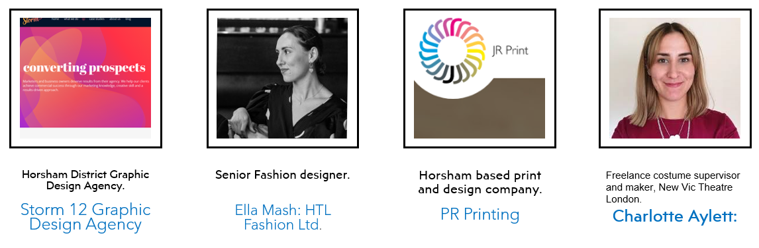 | What are the key messages employers have told us in the visual arts?  - RESEARCH: Strong, advanced research skills with genuine curiosity for the industry itself.  - COLLABORATION: The ability to openly collaborate , have good communication skills both verbally & digitally.  - PRACTICAL SKILLS: Strong prior learning in basic art & design skills but a willingness to adapt & learn new industry specific skills.  How do we promote these skills & values in our subject?  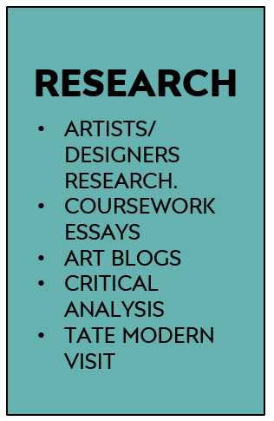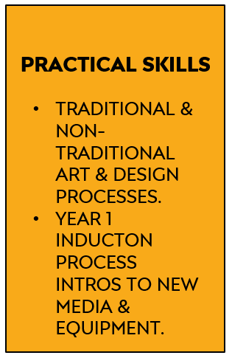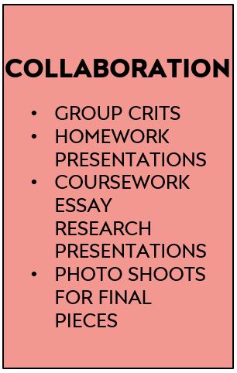  ERB 1 ERB 2 ERB 3
What do the Progress Review sections mean on this course?
- Progress Reviews in the A Level Art Department: for the purposes of self-assessment and teacher assessment, progress reviews are divided into:
- Performance grades: Performance Grades - A*-E for A Levels Year 2. Target (expected grade based on prior GCSEs). Current (grade you are currently working at. Estimated (an estimate of the grade you should realistically be able to achieve at the end of the course).
- Studentship grades: Studentship Grades - 1= outstanding, 2= good, 3= requires improvement, 4= serious cause for concern.
- Effort (commitment to study) - Hours per week of independent study per subject including:Teacher directed study – blog, life-drawing, homework tasks, coursework. Student directed study – consolidating learning, research or reading, skills practice, taking extra first-hand photos.
- Systems (organisation of study) Time Management - punctuality, completing planned study, completing homeworks, meeting deadlines. Organisation - bringing relevant equipment, sketchbooks, organisation of annotations, having work printed-out/presented on time.
- Practice (study behaviours) In class – full participation in lessons e.g. engaged listening, asking questions, contributing to discussion, using practical time well. Independent Study – practising skills as well as consolidating knowledge, , use of subject VLE, Pinterest, artists/designers blogs, visiting exhibitions & museums. Taking responsibility for learning – addressing problems, seeking help, using feedback constructively, attending subject workshops, identifying and avoiding distractions/barriers to learning.
- Attendance: Attendance - Percentage of classes attended in period. Punctuality - Percentage of classes attended on time in period.

How can I improve my progress in this subject?  A Level studentship can be easily improved by paying attention to the following points across all endorsements:  - Excellent attendance and punctuality; vital in practical subjects.  - Careful reading of this course’s Share Point each week to be clear of weekly tasks and use given resources to guide your work.  - If you miss a lesson for a valid reason; check Share Point to be prepared for the next lesson you attend; read the set work and watch any Power Points, videos used in class.  - Book-craft is very important:it includes quality titles, layout, annotation of work.  - Considered choices of artists and strong personal responses. |  | - Thoughtful Rod Taylor analysis of work using specialist vocabulary, see glossary on Share Point.  - Strong artists research from multiple sources.  - Handing all work in on time to allow for adequate verbal feedback and participate meaningfully in group crits of homeworks and final pieces.  - Act upon your feedback from your teacher.  - Attending workshops when you need extra 1-1 help on class or homeworks.
What methods do we use for assessment on the course?  Examples of some formative assessment methods we use every day in the Art Department:  - Establishing success criteria for the lesson, task, homework or section of coursework.  - Use of targeted closed questions exploring levels of understanding  - Use of open questioning to extend learning  - Self assessment/reflection  - Peer assessment  - Use of response partners/ small group  - Use of mini-plenaries during the lesson. |  | Examples of summative assessments we also use at specific times of the academic year:  - A final artifact for coursework - a print, drawing, painting, garment, textiles piece, digital piece.  - Year 2 exam sketchbook  - Year 2 exam 15 hour final exam piece.  - Year 1 Transfer Exam submission.  - A final essay – the 1000 word coursework essay.  - A component submission - the coursework or the exam unit.
What feedback do we use on the course?  Critiques (crits)  - Group homework crits each week or at key homework points.  - Lots of different formats from individually showing work to laying books in table for discussion.  - Final piece crits at the end of a final piece.  Use of Exemplar work in the class-room:  - Group discussion of excellent homeworks for inspiration.  - Group discussions of excellent processes, eg printmaking, dye samples etc.  - Share Point exemplar Power Points.  - Pinterest examples on Susie’s site. |  | Others:  - 1-1s with staff formally & informally in class.  - Post-it notes in sketchbooks for improvement suggestions.  - Teams feedback for Graphics.  - Year 1 Transfer Feedback sheet with actions.
How does the work support the Collyers Policy on British Values?  - The selection of artists, designers and makers complies and acknowledges the precepts identified by the  college clearly in both Pro Study and the core curriculum; Democracy,The rule of Law,Individual liberty,  Mutual Respect,Tolerance of different faiths and beliefs. |  | 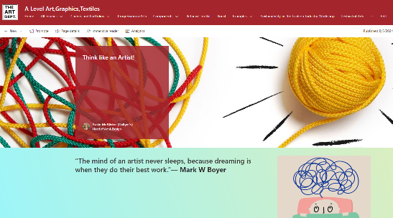  It is an essential part of your growth as an artist to understand what factors can drive individual creativity,  see the Think Like an Artist section on Share Point.

