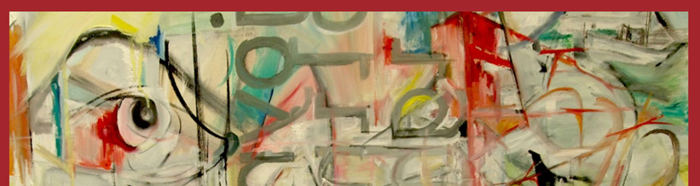 |  |  |  |  |  | ART DEPARTMENT SCHEME OF WORK for staff & students.
 |  |  |  |  |  | Course: A Level Fine Art
 |  |  |  |  |  | Year Group: Year 2
 |  |  |  |  |  | Teachers:Ian McAlister, Susie McAlister.
EDUQAS Assessment Objectives for this course are:  AO1 Contextual Understanding 25%. Develop ideas through sustained and focused investigations informed by contextual and other sources, demonstrating analytical and critical understanding.  AO2 Creative Making 25%. Explore and select appropriate resources, media, materials, techniques and processes, reviewing and refining ideas as work develops.  AO3 Reflective Recording 25%. Record ideas, observations and insights relevant to intentions, reflecting critically on work and progress.  AO4 Personal Presentation 25%. Present a personal and meaningful response that realises intentions and, where appropriate, makes connections between visual and other elements. |  |  |  |  | Our Employer Representative Board (see FAQs) for the Visual Arts recommendations help us to understand how knowledge and skills developed within the subject supports your progression into the world of work and link strongly with the EDUQAS AOs, as demonstrated in the first few weeks of the curriculum below.  ERB 1: Research: Strong, advanced research skills with genuine curiosity for the industry itself.  ERB 2: Practical skills: Strong prior learning in basic art & design skills but a willingness to adapt & learn new industry specific skills.  ERB 3: Collaboration: The ability to openly collaborate , have good communication skills both verbally & digitally.
Week | Date | A Level Course Class work: | A Level Course Homework (5 hours): | Resources available/needed: |  | Pro Study:  Designed to introduce a breadth of contemporary artists, designers or practices which help define arts place in society & inclusive, diverse creativity. | Curriculum support & breadth:  This section highlights the other areas of the wider Arts curriculum: to include workshops, open studios, enrichment, planned trips, talks, competitions week by week during the year.
3 | Sept 9 | Mock Exam  PLANNING  Lessons & homeworks:  - In coursework book: add heading of Summer Final Piece.  - Add a printed-out photo of the section/s of your concertina you are working from.  - Brainstorm 1 page+ Using ideas from your concertina book as a starting point, quotes, general references, internet/artists examples, your own ideas. Try to be thorough, inventive and think laterally.  - Thumbnails: 1 page+ of thumbnail sketches from ideas directly from your concertina book.  - Discuss your chosen mock idea with your teacher. | Completion of the work in class for the mock. | Files & visual examples on subject Share Point:  Year 2 format Power Point.  Previous student examples for the exam FMPs PP  Media experiments reminder PP.  Creative making suggestions Doc.  *Timesheet on Share Point to download and use for the Mock. |  | Tate Shots:How this painting Campaigned for Women’s Rights. | Workshops:Tues p2, Thurs 1.20pm lunch.  Open Studios: see timetable on doors for free rooms to work.  Lunchtimes: supervised open studios Mon-Fri.  Enrichment: 360-Y2 HE Portfolio Development Fridays, 2 sessions in D101 & D103.
4 & 5 | 16+ 23 | Mock Exam  MAKING  Make the final piece/s using lessons and homework time up to 15 hours. Use the timesheet given to record your timings.  Photograph and document the progress of the final piece in your book. | Completion of the mock FMP work in class, remember to keep time sheet up to date to onitor how you use the 15 hours. | Files & visual examples on subject Share Point:  Retreival Toolkit PP & videos for all media & processes.  Media experiments reminder PP.  Creative making suggestions Doc. |  | Tate Shots: Olafur Eliasson- Collective Experience  Tate Shots: Billie Zangewa ‘the ultimate Act of Resistance is Self Love’ | Workshops:Tues p2, Thurs 1.20pm lunch.  Open Studios: see timetable on doors for free rooms to work.  Lunchtimes: supervised open studios Mon-Fri.  Enrichment: 360- Y2 HE Portfolio Development Fridays, 2 sessions in D101 & D103.
6 | 30 | Planning for FINAL MAJOR PROJECT  Brainstorm Use a combination of written ideas, thumbnail drawings, cuttings and internet images  Initial Thumbnails 2 pages of initial thumbnails - inventive and varied to give you ideas for the project.  Review of ideas-Which excite  Refined thumbnails: ideas from your initial thumbnails you want to explore further. | Refined thumbnails: decide which ideas from initial thumbnails work and which to explore further.  Make exploratory sketches, colour studies to refine idea to a refined thumbnail proposal for your FMP.  Add any photos that are relevant from concertina book, printmaking etc as examples of where the ideas have come from. | ON SHAREPOINT  POWERPOINT PRESENATION  Final Major Project explanation and Time line  Visual examples of task for Thumbnails  Brainstorming  Refined Thumbnails  Task Sheet to aid in development of Creative making with artist reference and planning included |  | Tate Shots: Jason Evan- Culture is Everything we do. | Workshops:Tues p2, Thurs 1.20pm lunch.  Open Studios: see timetable on doors for free rooms to work.  Lunchtimes: supervised open studios Mon-Fri.  Enrichment: 360 Y2 HE Portfolio Development Fridays, 2 sessions in D101 & D103.
7 & 8 | Oct 7+  14 | FMP final plan:  Make a double page plan of your final idea/s for the FMP. This should be an  enhanced thumbnail with notes on  *colour schemes  *compositional alternatives labelled with focal point use of directional planes, foreground, middleground, background etc.  *use of media.  Use the example below to inform your choices.  Start the FMP (or small maquette/test piece if needed).  . | AO3 RECORD  Task: Using your first hand photos FROM THE CONCERTINA BOOK to demonstrate your recording skills by producing responses to the following 4 formal elements of Art and Design. You have homework for 2 weeks + Half Term to complete this work: 10 hours, with 8 hours of drawing below, 2 hours thinking time to work out what to do for each formal element. This needs to be QUALITY work, if you want to do it larger than your book then photograph it into the book as well:  Each response should take 2 hours and use at least one full page of your book.  You should make at least four full pages of work  - LINE : Make a line drawing using more than one colour of line. This should be in detail you might like to explore using the colours to indicate foreground middle ground and background. Media = pen – coloured pencil – ink - acrylic -digital drawing  - SHAPE: Using blocks of colour develop a response that uses no line. Media = paint, collage, coloured pencil, pen, digital formats, photoshop, procreate.  - SPACE: Investigate the use of negative space by only using black to indicate negative space. Media = Pen, ink, marker, digital media, photoshop, procreate.  - TEXTURE: Replicate and explore a texture in paint, collage, digital, or any mixed media magic. Find ways to show texture, create texture or give the illusion of texture. For instance scratching into wet paint for fur or building up layers of tissue for close ups of skin. Media as appropriate. | Files & visual examples on subject Share Point:  PDF task visual examples and explanations for Formal Elements work.  PP AO3 recording examples for this task. |  | Tate Shots: Franz Erhard Walther – ‘It Jumps out of Time’  Tate Shots: Why study Art? | Workshops:Tues p2, Thurs 1.20pm lunch.  Open Studios: see timetable on doors for free rooms to work.  Lunchtimes: supervised open studios Mon-Fri.  Enrichment: Drop-in: Fridays 12.15pm: Y1&2 Careers advice, portfolios, interview practice.  Trip: Leonardslee Gardens with Surrey Sculpture Society, see Share Point for details.
9 | 21 | FMP development in class, individual in its nature. This could be experimental maquettes, learning a new technique or media/technology or starting the actual final piece. | Lesson: FMP in class Homework: 6 hours, 2 double page minimum in sketchbook from task set below:  - Present any new photos needed for the FMP that are not in your concertina, be thorough -this includes reference figures, portraits, trees, skies, buildings, details of things etc.  - Practice Drawings in any media, traditional or digital of any subject related to your FMP. These MUST be from your first-hand reference photos from your concertina or as above. You can only use second hand references from the internet for unusual things you could not reasonably photograph yourself eg. the moon, underwater submarines, tigers etc. These can only be photographs, not artists work. You must declare where these second hand images have come from eg. web addresses. | Files & visual examples on subject Share Point:  PDF task visual examples and explanations for Formal Elements work.  PP AO3 recording examples for this task. |  | Tate Shots: Richard Deacon -Think Like an Artist. | Workshops:Tues p2, Thurs 1.20pm lunch.  Open Studios: see timetable on doors for free rooms to work.  Lunchtimes: supervised open studios Mon-Fri.  Enrichment: Drop-in: Fridays 12.15pm: Y1&2 Careers advice, portfolios, interview practice.  Competition:Design mural for new Common Room space, see Share Point for details.
 |  | HALF TERM
10 | Nov 4 | Monday: INSET DAY  FMP development in class, individual in its nature. This could be experimental maquettes, learning a new technique or media/technology or starting the actual final piece. | COLOUR A01&2  Lesson: FMP in class Homework: 6 hours, 2 double page minimum in sketchbook from task set below:  Find an artist's image (painting, drawing, photography, digital, sculpture) which you really admire the colour scheme of (if black & white then the mark-making you like). Print off and present in your book explaining why it inspires you for your FMP. Is it the atmosphere created? harmonising or clashing colours?  Make a chart of the colours used, presented in your own way. You can use magazine cuttings, paint, pens, pastel, collage, Photoshop, procreate etc to recreate the colours.  Create 3 alternative colour palettes for your own FMP. Present imaginatively and explain your choices: are they realistic, pop art, modern illustration, fashionable, traditional, futuristic, cold colours, pastels, warm colours, black & white, grey-scale...  Make a test of a small section of your FMP with these colours (in 2D, 3D or digital) | Share Point:  Pdf: See Visual example.  Retreival Toolkit.  Y1 share point previous exercise. |  | Tate Shots: Frank Bowling -from figuration to Abstraction. | Workshops:Tues p2, Thurs 1.20pm lunch.  Open Studios: see timetable on doors for free rooms to work.  Lunchtimes: supervised open studios Mon-Fri.  Enrichment: Drop-in: Fridays 12.15pm: Y1&2 Careers advice, portfolios, interview practice.
11 | 11 | FMP development in class, individual in its nature. This could be experimental maquettes, learning a new technique or media/technology or starting the actual final piece. | COMPOSITION AO1  Homework: 6 hours, 2 double page minimum in sketchbook from task set below:  Choose and print-off a relevant piece of artists work that inspires you when making your FMP, that can be because of the media, colours or subject matter.  Now label the following on the artist' image:  * focal point,  rule of 1/3ds, *foreground/middleground/  background,  *direction of light,  *picture planes - diagonals, horizontals & verticals.  Use the Composition Power Point below from Year 1 as a reminder to help.  - Complete the Rod Taylor analysis below on the chosen piece of work. | Share Point:  Composition PP  Rod Taylor questions sheet.  Pdf: Visual example of exercise. |  | Tate Shots: LGBTQ+ and Icons at Tate Britain. | Workshops:Tues p2, Thurs 1.20pm lunch.  Open Studios: see timetable on doors for free rooms to work.  Lunchtimes: supervised open studios Mon-Fri.  Enrichment: Drop-in: Fridays 12.15pm: Y1&2 Careers advice, portfolios, interview practice.
12 | 18 | FMP development in class, individual in its nature. This could be experimental maquettes, learning a new technique or media/technology or starting the actual final piece. | DOCUMENTATION A01,AO2,AO4  2 double page minimum in sketchbook from task set below:  1 double page minimum of fully documented FMP progress including photos and/or screen shots of the process of making the piece/s, any test pieces and discussing the problems you encountered, changes you made to make the piece work. This should be a full discussion with the examiner.  1 page photo of final piece in progress preseneted in sketchbook and annotated fully with compositional notes as last week's excercise: eg*focal point, rule of 1/3ds, foreground /middleground/background, direction of light, picture planes - diagonals, horizontals & verticals. | Share Point:  Supporting Studies PP. |  | Tate Shots: Marlen Dumas on Rejects. | Workshops:Tues p2, Thurs 1.20pm lunch.  Open Studios: see timetable on doors for free rooms to work.  Lunchtimes: supervised open studios Mon-Fri.  Enrichment: Drop-in: Fridays 12.15pm: Y1&2 Careers advice, portfolios, interview practice.
13+14 | 25+ Dec 2 | CREATIVE MAKING:  TASK: *Make: a minimum 4 quality experiments (almost mini final pieces), fully documented and annotated.  This can be small painting experiments with different surfaces, textures, background colours. Small 3d experiments using air -drying clay, folded paper, found objects, photographed well with light and shadows. This could be observational drawings moved onto Photoshop or Procreate, prints on fabric which are then sewn into. | Present in sketchbook - it's the DOCUMENTATION that is important in these 2 weeks - like a making diary, use photos if the work is too large, 3D or screenshots for digital work.  USE: your concertina and other 1st hand imagery you have documented in your sketchbook. You can take new photos if needed. Think about this as an extension of the formal elements exercises in the Week 5 homework. | .Pdf Creative Making sheet.  Creative making examples PP.  Sketchbook page examples. |  | Tate Shots: Paula Rego at the Curwen Studios. | Workshops:Tues p2, Thurs 1.20pm lunch.  Open Studios: see timetable on doors for free rooms to work.  Lunchtimes: supervised open studios Mon-Fri.  Enrichment: Drop-in: Fridays 12.15pm: Y1&2 Careers advice, portfolios, interview practice.
15 | 9 | Lesson: FMP in class | FMP continuation |  |  | Continue building your Tate Shots blog weekly but with artists, designers, craftspeople who specifically relate to your project/exam work. | Workshops:Tues p2, Thurs 1.20pm lunch.  Open Studios: see timetable on doors for free rooms to work.  Lunchtimes: supervised open studios Mon-Fri.  Enrichment: Drop-in: Fridays 12.15pm: Y1&2 Careers advice, portfolios, interview practice.  Trip: Tate Britain: Turner Prize and ‘Now you see Us’ -see Share Point for details.
16 | 16 | Wed: Term Ends.  FMP in class | Rewrite and present coursework final essay in sketchbook.  Print-out and add final Pro Study blog entries into coursework sketchbook. | Share Point:  See all essay research and writing resources in Year 1 Fine Art or Retreival Toolkit. |  | Continue building your Tate Shots blog weekly but with artists, designers, craftspeople who specifically relate to your project/exam work. | Workshops:Tues p2, Thurs 1.20pm lunch.  Open Studios: see timetable on doors for free rooms to work.  Lunchtimes: supervised open studios Mon-Fri.  Enrichment: Drop-in: Fridays 12.15pm: Y1&2 Careers advice, portfolios, interview practice.
 |  | END OF TERM
17 + 18 | Jan 6+ 13 | Lessons and homeworks: Two Weeks lessons and homeworks to complete FMPs and document in sketchbook. |  | Share Point:  Documentation PP in Retreival Toolkit. |  | Continue building your Tate Shots blog weekly but with artists, designers, craftspeople who specifically relate to your project/exam work. | Workshops:Tues p2, Thurs 1.20pm lunch.  Open Studios: see timetable on doors for free rooms to work.  Lunchtimes: supervised open studios Mon-Fri.  Enrichment: Drop-in: Fridays 12.15pm: Y1&2 Careers advice, portfolios, interview practice.
19 | 20 | Lesson: FMP completion and then move onto homework documentation and connections task. | FINAL DOCUMENTATION & CONNECTIONS AO1&2,4.  Homework: 6 hours, 2 double page minimum in sketchbook from task set below:  - 1 double page+ of fully documented FMP including photos and/or screen shots of the process of making the piece/s and discussing the problems you encountered, changes you made to make the piece work. This should be a full discussion with the examiner.  - Photo of final piece/s in sketchbook.  - 1 double page making connections between your FMPs and the artists who have inspired you to make them. Use the Word Doc in this section or write/type freehand. | Share Point: Coursework Connections sheet to down load and complete. |  | Continue building your Tate Shots blog weekly but with artists, designers, craftspeople who specifically relate to your project/exam work. | Workshops:Tues p2, Thurs 1.20pm lunch.  Open Studios: see timetable on doors for free rooms to work.  Lunchtimes: supervised open studios Mon-Fri.  Enrichment: Drop-in: Fridays 12.15pm: Y1&2 Careers advice, portfolios, interview practice.
20 | 27 | LEARNER STATEMENT:  Complete the Learner Statement typed or hand-written.  Complete all highlighted sections fully.  Print out the completed form and give to your teacher on submission of coursework. |  | Share Point:  Example completed Learner Statement for Component 1 Fine Art.  Blank Word Doc Learner Statement to download and complete. |  | Continue building your Tate Shots blog weekly but with artists, designers, craftspeople who specifically relate to your project/exam work. | Workshops:Tues p2, Thurs 1.20pm lunch.  Open Studios: see timetable on doors for free rooms to work.  Lunchtimes: supervised open studios Mon-Fri.  Enrichment: Drop-in: Fridays 12.15pm: Y1&2 Careers advice, portfolios, interview practice.
21  Y2 EXAM | Feb 3 | EXAM:  Lessons: Pen & ink drawings of real objects you bring in connected to your question theme (2 double pages minimum).  Extension: watercolour /collage or Photoshop/digital colour version from drawings. | 6 HOURS Homework: Double page research on still life artists Cotan and the Surrealist Magritte’s use of objects in surreal rooms or combining objects. Then: Double page photos of still life in your question theme, chosen style and response, any media. | Share Point resources:  Whole sketchbook example page by page.  Stages of FMP PP.  1st 4 weeks of exam PP. |  | Continue building your Tate Shots blog weekly but with artists, designers, craftspeople who specifically relate to your exam work.  This will boost your AO1 & 3 marks for the exam. | Workshops:Tues p2, Thurs 1.20pm lunch.  Open Studios: see timetable on doors for free rooms to work.  Lunchtimes: supervised open studios Mon-Fri.  Enrichment: Drop-in: Fridays 12.15pm: Y1&2 Careers advice, portfolios, interview practice.
22 | Feb 10 | Create a beautifully crafted 1 colour lino print from your still life homework last week.  Follow instructions below to prepare the 1 colour lino for your theme.  Extension work: take the prints further, no 2 prints should be the same in your book. eg. prepar colour/collages paper for printing the lino, hand colour prints, colour using Photoshop or procreate, create complex Photoshop repeat patterns etc. | 6 HOURS Homework: Double page research into Lucas Simoes portraits and Michael Mapes. Double page response to either artist using your own photos relevant to your exam question. | Share Point resources:  Pdf Photoshop for lino reminder sheet.  Lino Process with examples PP.  Examples of linos for task. |  | Continue building your Tate Shots blog weekly but with artists, designers, craftspeople who specifically relate to your exam work. | Workshops:Tues p2, Thurs 1.20pm lunch.  Open Studios: see timetable on doors for free rooms to work.  Lunchtimes: supervised open studios Mon-Fri.  Enrichment: Drop-in: Fridays 12.15pm: Y1&2 Careers advice, portfolios, interview practice.
 |  | HALF TERM
23 | 24 | MON: INSET DAY  Shaped, layered, complex etching from Week 2 homework response. | Take etchings into Photoshop, Procreate, onto fabric & embroider, collage, watercolour etc. Present in your book. | Share Point resources:  SHAPED ETCHINGS on Susie's Pinterest board https://www.pinterest.co.uk/mcalister0696/etchings-shaped/  Scanning into Photoshop helper sheet. |  | Continue building your Tate Shots blog weekly but with artists, designers, craftspeople who specifically relate to your exam work. | Workshops:Tues p2, Thurs 1.20pm lunch.  Open Studios: see timetable on doors for free rooms to work.  Lunchtimes: supervised open studios Mon-Fri.  Enrichment: Drop-in: Fridays 12.15pm: Y1&2 Careers advice, portfolios, interview practice.
24 | Mar 3 | Task for lessons and homework (10 hours) : Complete all 3 weeks above for submission with a title page for the exam question you have chosen.  SUBMIT: Monday March 10 in class for grade. | Make sure all above work is completed, annotated and titled. | Share Point resources:  Supporting Studies PP  How to get high grades in the first 4 weeks pointers. |  | Continue building your Tate Shots blog weekly but with artists, designers, craftspeople who specifically relate to your exam work. | Workshops:Tues p2, Thurs 1.20pm lunch.  Open Studios: see timetable on doors for free rooms to work.  Lunchtimes: supervised open studios Mon-Fri.  Enrichment: Drop-in: Fridays 12.15pm: Y1&2 Careers advice, portfolios, interview practice.
25 | 10 | Brainstorm - Using ideas from the exam paper as a starting point, quotes, general references, your own ideas. Try to be thorough, inventive and think laterally. Use a combination of written ideas, thumbnail drawings, cuttings and internet images to make the brainstorm look visually exciting. (DOUBLE PAGE.)  Mood Board- Choose an area of the brainstorm to investigate as a starting point, collect second hand ideas, cuttings from magazines, internet, web sites, articles, photos, poems, lyrics etc. on the general theme.(DOUBLE PAGE) | 2 pages of initial thumbnail ideas in pencil or pen (DOUBLE PAGE) including a Review of ideas-Which excite you from the above ideas, which are dead ends and why. What do you need to do next? ( HALF PAGE REVIEW) | Share Point resources:  Guidance for Exam Week 5 PP.  Visual Examples. |  | Continue building your Tate Shots blog weekly but with artists, designers, craftspeople who specifically relate to your exam work. | Workshops:Tues p2, Thurs 1.20pm lunch.  Open Studios: see timetable on doors for free rooms to work.  Lunchtimes: supervised open studios Mon-Fri.  Enrichment: Drop-in: Fridays 12.15pm: Y1&2 Careers advice, portfolios, interview practice.
26 | 17 | LESSONS:  - Research of artists and designers for your exam question- Collect/ present at least 2 artists you have chosen in a coherent and exciting way, 2 double pages.  - Complete a Rod Taylor analysis on one of the artists pieces of work  - Add a compositional deconstruction of the Rod Taylor image. | Respond to 1 of the artists using any media and your chosen theme. Present in your book either as the artwork or photo of it, if 3d, textiles, too large etc. | Share Point resources:  Starter list of artists by theme as a resource starting point.  Rod Taylor questions.  Composition PP. |  | Continue building your Tate Shots blog weekly but with artists, designers, craftspeople who specifically relate to your exam work. | Workshops:Tues p2, Thurs 1.20pm lunch.  Open Studios: see timetable on doors for free rooms to work.  Lunchtimes: supervised open studios Mon-Fri.  Enrichment: Drop-in: Fridays 12.15pm: Y1&2 Careers advice, portfolios, interview practice.
27 | 24 | Final Thumbnail sketches- Final ideas should be leaping out of the pages by now, sketch the ideas, have at least 3-5 alternatives – do not be restricted by how difficult the ideas may be at this stage. (2 page minimum) | Homework: Refine, modify your best ideas. ( 2 PAGE MINIMUM.)- Present as an ENHANCED thumbnail but experiment with:  - alternative final ideas  - alternative composition  - choice of media  - format; shape of image, scale  - number of outcomes  - typography  - colour swatches. | Share Point resources:  Retreival Toolkit: refined thumbnail examples. |  | Continue building your Tate Shots blog weekly but with artists, designers, craftspeople who specifically relate to your exam work. | Workshops:Tues p2, Thurs 1.20pm lunch.  Open Studios: see timetable on doors for free rooms to work.  Lunchtimes: supervised open studios Mon-Fri.  Enrichment: Drop-in: Fridays 12.15pm: Y1&2 Careers advice, portfolios, interview practice.
28 | 31 | Fri: Y2 Founders Day Leavers Festival.  Final planning for the actual exam: make sure your book has a clear, annotated and detailed final enhanced thumbnail of what you are going to make in the exam.  Complete the attached Connections Form and stick it into your book (worth lots of marks!). | Take your final first-hand photographs for your exam FMP. Present beautifully and imaginatively in your book. | Share Point resources:  Easter exam photos PP.  Connections sheet to download and complete. |  | Continue building your Tate Shots blog weekly but with artists, designers, craftspeople who specifically relate to your exam work. | Workshops:Tues p2, Thurs 1.20pm lunch.  Open Studios: see timetable on doors for free rooms to work.  Lunchtimes: supervised open studios Mon-Fri.  Enrichment: Drop-in: Fridays 12.15pm: Y1&2 Careers advice, portfolios, interview practice.
 |  | EASTER HOLIDAYS
29 | April22 | Make any prep work for the exam, eg. any 3d elements, cutting canvas board to required shapes and sizes, staining and drawing/projecting outlines onto canvases. | PRACTICE drawing to get your skills ready for the 15 hour exam : from your photos taken during Easter, NOT the ones you are directly using in the exam: drawing/recording experiments around your theme, change scale, small sections, experiment with colour, texture, pattern, shadow, light etc. Any media: traditional, digital, collage, textiles, clay etc to suit your theme. (2 DOUBLE PAGES MIN). | Share Point resources:  Easter exam photos PP. |  | Continue building your Tate Shots blog weekly but with artists, designers, craftspeople who specifically relate to your exam work. | Workshops:Tues p2, Thurs 1.20pm lunch.  Open Studios: see timetable on doors for free rooms to work.  Lunchtimes: supervised open studios Mon-Fri.  Enrichment: Drop-in: Fridays 12.15pm: Y1&2 Careers advice, portfolios, interview practice.
30 | 28 | Complete any preparation for the 15 hour exam final piece; 3d structure, prepare canvases, cut any shaped canvases, prime them with Gesso etc. draw-up final exam piece, organise digital images onto a memory stick (remember no internet access during the exam). | Learner Statement for Component 2 below with example questions. Use your previous CONNECTIONS SHEET to help gain as many extra marks as possible. | Share Point resources:  Example Exam learner Statement and blank Learner Statement to download and complete. |  | Print out all relevant blog entries and present in your exam sketchbook. | Workshops:Tues p2, Thurs 1.20pm lunch.  Open Studios: see timetable on doors for free rooms to work.  Lunchtimes: supervised open studios Mon-Fri.  Enrichment: Drop-in: Fridays 12.15pm: Y1&2 Careers advice, portfolios, interview practice.
31  ART EXAM PERIOD | May 5 | Mon: Bank Holiday  PRACTICAL A LEVEL ARTS EXAMS: ALL ROOMS.  Y1 online work. | n/a | n/a |  | n/a | Support during practical exam period: email  Susie: sem@collyers.ac.uk or  Ian: IM@collyers.ac.uk or  Amanda: AH@collyers.ac.uk.
32 | 12 | PRACTICAL A LEVEL ARTS EXAMS: ALL ROOMS.  Y1 online work. | n/a | n/a |  | n/a | Support during practical exam period: email  Susie: sem@collyers.ac.uk or  Ian: IM@collyers.ac.uk or  Amanda: AH@collyers.ac.uk.
33 | 19 | College Study Leave Y1&Y2  All marks submitted to EDUQAS. |  |  |  |  | Support during practical exam period: email  Susie: sem@collyers.ac.uk or  Ian: IM@collyers.ac.uk or  Amanda: AH@collyers.ac.uk.

FAQs: (frequently asked questions)
What is ERB?  It is our Employer Representative Board for the Visual Arts.  - A panel of 3 employers who engage with our subject annually to provide us with information about progression routes in their industry.  - They help us to understand the skills and qualities employers look for when recruiting early careers candidates (post-18 employment, apprenticeships and graduate level jobs).  - Engagement with local and national employers helps teachers to understand how knowledge and skills developed within the subject supports your progression into the world of work.  Who are our Visual Arts Employer Links?  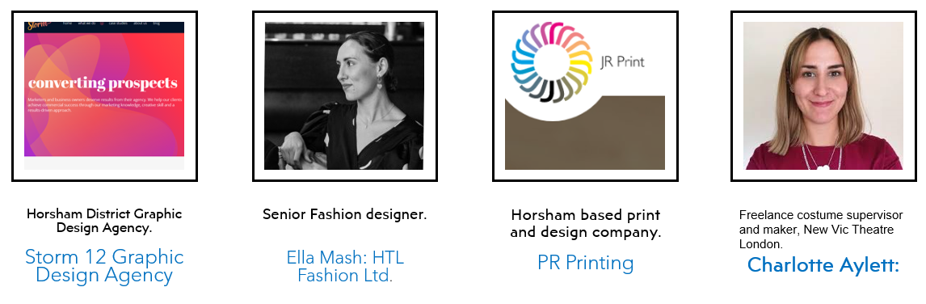 | What are the key messages employers have told us in the visual arts?  - RESEARCH: Strong, advanced research skills with genuine curiosity for the industry itself.  - COLLABORATION: The ability to openly collaborate , have good communication skills both verbally & digitally.  - PRACTICAL SKILLS: Strong prior learning in basic art & design skills but a willingness to adapt & learn new industry specific skills.  How do we promote these skills & values in our subject?  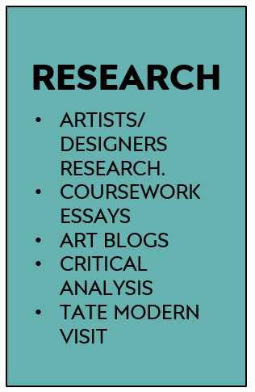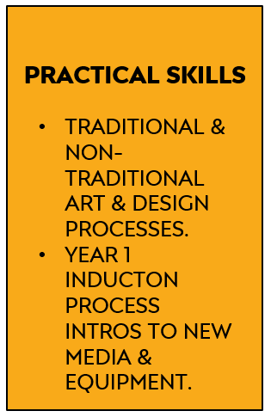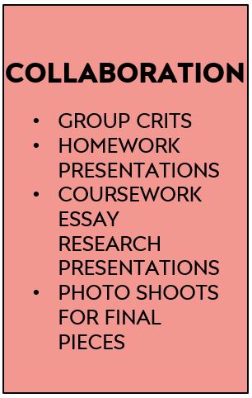  ERB 1 ERB 2 ERB 3
What do the Progress Review sections mean on this course?
- Progress Reviews in the A Level Art Department: for the purposes of self-assessment and teacher assessment, progress reviews are divided into:
- Performance grades: Performance Grades - A*-E for A Levels Year 2. Target (expected grade based on prior GCSEs). Current (grade you are currently working at. Estimated (an estimate of the grade you should realistically be able to achieve at the end of the course).
- Studentship grades: Studentship Grades - 1= outstanding, 2= good, 3= requires improvement, 4= serious cause for concern.
- Effort (commitment to study) - Hours per week of independent study per subject including:Teacher directed study – blog, life-drawing, homework tasks, coursework. Student directed study – consolidating learning, research or reading, skills practice, taking extra first-hand photos.
- Systems (organisation of study) Time Management - punctuality, completing planned study, completing homeworks, meeting deadlines. Organisation - bringing relevant equipment, sketchbooks, organisation of annotations, having work printed-out/presented on time.
- Practice (study behaviours) In class – full participation in lessons e.g. engaged listening, asking questions, contributing to discussion, using practical time well. Independent Study – practising skills as well as consolidating knowledge, , use of subject VLE, Pinterest, artists/designers blogs, visiting exhibitions & museums. Taking responsibility for learning – addressing problems, seeking help, using feedback constructively, attending subject workshops, identifying and avoiding distractions/barriers to learning.
- Attendance: Attendance - Percentage of classes attended in period. Punctuality - Percentage of classes attended on time in period.

How can I improve my progress in this subject?  A Level studentship can be easily improved by paying attention to the following points across all endorsements:  - Excellent attendance and punctuality; vital in practical subjects.  - Careful reading of this course’s Share Point each week to be clear of weekly tasks and use given resources to guide your work.  - If you miss a lesson for a valid reason; check Share Point to be prepared for the next lesson you attend; read the set work and watch any Power Points, videos used in class.  - Book-craft is very important:it includes quality titles, layout, annotation of work.  - Considered choices of artists and strong personal responses. |  | - Thoughtful Rod Taylor analysis of work using specialist vocabulary, see glossary on Share Point.  - Strong artists research from multiple sources.  - Handing all work in on time to allow for adequate verbal feedback and participate meaningfully in group crits of homeworks and final pieces.  - Act upon your feedback from your teacher.  - Attending workshops when you need extra 1-1 help on class or homeworks.
What methods do we use for assessment on the course?  Examples of some formative assessment methods we use every day in the Art Department:  - Establishing success criteria for the lesson, task, homework or section of coursework.  - Use of targeted closed questions exploring levels of understanding  - Use of open questioning to extend learning  - Self assessment/reflection  - Peer assessment  - Use of response partners/ small group  - Use of mini-plenaries during the lesson. |  | Examples of summative assessments we also use at specific times of the academic year:  - A final artifact for coursework - a print, drawing, painting, garment, textiles piece, digital piece.  - Year 2 exam sketchbook  - Year 2 exam 15 hour final exam piece.  - Year 1 Transfer Exam submission.  - A final essay – the 1000 word coursework essay.  - A component submission - the coursework or the exam unit.
What feedback do we use on the course?  Critiques (crits)  - Group homework crits each week or at key homework points.  - Lots of different formats from individually showing work to laying books in table for discussion.  - Final piece crits at the end of a final piece.  Use of Exemplar work in the class-room:  - Group discussion of excellent homeworks for inspiration.  - Group discussions of excellent processes, eg printmaking, dye samples etc.  - Share Point exemplar Power Points.  - Pinterest examples on Susie’s site. |  | Others:  - 1-1s with staff formally & informally in class.  - Post-it notes in sketchbooks for improvement suggestions.  - Teams feedback for Graphics.  - Year 1 Transfer Feedback sheet with actions.
How does the work support the Collyers Policy on British Values?  - The selection of artists, designers and makers complies and acknowledges the precepts identified by the  college clearly in both Pro Study and the core curriculum; Democracy,The rule of Law,Individual liberty,  Mutual Respect,Tolerance of different faiths and beliefs. |  | 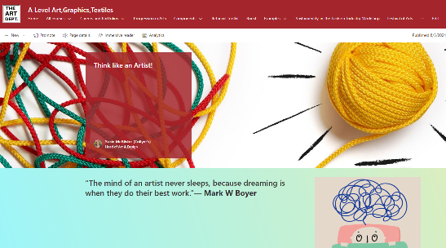  It is an essential part of your growth as an artist to understand what factors can drive individual creativity,  see the Think Like an Artist section on Share Point.

