 |  |  |  |  |  | ART DEPARTMENT SCHEME OF WORK for staff & students.
 |  |  |  |  |  | Course: Graphic Communication
 |  |  |  |  |  | Year Group: Year One
 |  |  |  |  |  | Teachers: AH
EDUQAS Assessment Objectives for this course are:  AO1 Contextual Understanding 25%. Develop ideas through sustained and focused investigations informed by contextual and other sources, demonstrating analytical and critical understanding.  AO2 Creative Making 25%. Explore and select appropriate resources, media, materials, techniques and processes, reviewing and refining ideas as work develops.  AO3 Reflective Recording 25%. Record ideas, observations and insights relevant to intentions, reflecting critically on work and progress.  AO4 Personal Presentation 25%. Present a personal and meaningful response that realises intentions and, where appropriate, makes connections between visual and other elements. |  |  |  |  | Our Employer Representative Board (see FAQs) for the Visual Arts recommendations help us to understand how knowledge and skills developed within the subject supports your progression into the world of work and link strongly with the EDUQAS AOs, as demonstrated in the first few weeks of the curriculum below.  ERB 1: Research: Strong, advanced research skills with genuine curiosity for the industry itself.  ERB 2: Practical skills: Strong prior learning in basic art & design skills but a willingness to adapt & learn new industry specific skills.  ERB 3: Collaboration: The ability to openly collaborate , have good communication skills both verbally & digitally.
Week | Date | A Level Course Class work: | A Level Course Homework (5 hours): | Resources available/needed: |  | Pro Study:  Designed to introduce a breadth of contemporary artists, designers or practices which help define arts place in society & inclusive, diverse creativity. | Curriculum support & breadth:  This section highlights the other areas of the wider Arts curriculum: to include workshops, open studios, enrichment, planned trips, talks, competitions week by week during the year.
3 | Sept 9 | Choose your theme from the list on sharepoint - discuss with teacher  Make an A3 hand written mindmap of all associated with theme -at least 30 things!  Consider:  Words – People - Places – Music – Film – Books -TV Programs – Products – Fashion - Objects -Brands -Companies – Charities Organisations ( eg Scouts, cancer Research, Apple, etc) – photographs you could take - all associated with the theme  Lessons & Homework for these 2 weeks to present your brainstorm and 20 photographs beautifully for the Examiner to introduce them to your coursework. | Homework:  - Complete presentation of brainstorm.  - Take photographs on your phone connected with your theme, you do not have to travel or buy anything - use your design skills to select images around you. eg. a bus, train station or walking boots for travel, a friends Pride flag for love, the gym for entertainment (not pics of poeple without their permission!), selections of colourful fruit for nourishment.  - Select the best 20 and present beautifully on an A3 sheet either digitally in Photoshop, Word, Procreate or collaged onto an A3 sheet from print outs. | Resources available in D101 & PC and Printer  Magazines & newspapers first hand photos written materials art supplies card paper photocopied images  Additional PRESENTATIONS  *Available on Sharepoint |  | ALL PROSTUDY TO BE PRESENTED AS REVIEW OF VIDEOS AND DEMONSTRATION OF SKILLS IN SEPARATE FOLDER SECTION  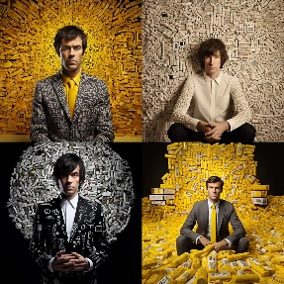  Designing with slogans - Stefan Sagmeister  WITTY – BRILLIANT – UNBELEIVABLE - IDEAS IN ACTION - PERFORMANCE TYPOGRAPHY  Amazing ideas designed and brought TO LIFE BY BRAVE PARTICIPATION  https://youtu.be/2OUFCyKr-t0 | Workshops:Tues p2, Thurs 1.20pm lunch.  Open Studios: see timetable on doors for free rooms to work.  Lunchtimes: supervised open studios Mon-Fri.  Enrichment: 360-Y2 HE Portfolio Development Fridays, 2 sessions in D101 & D103.
4 | 16 | Choose your theme from the list on sharepoint - discuss with teacher  Make an A3 hand written mindmap of all associated with theme -at least 30 things!  Consider:  Words – People - Places – Music – Film – Books -TV Programs – Products – Fashion - Objects -Brands -Companies – Charities Organisations ( eg Scouts, cancer Research, Apple, etc) – photographs you could take - all associated with the theme  Lessons & Homework for these 2 weeks to present your brainstorm and 20 photographs beautifully for the Examiner to introduce them to your coursework. | Homework:  - Complete presentation of brainstorm.  - Take photographs on your phone connected with your theme, you do not have to travel or buy anything - use your design skills to select images around you. eg. a bus, train station or walking boots for travel, a friends Pride flag for love, the gym for entertainment (not pics of poeple without their permission!), selections of colourful fruit for nourishment.  - Select the best 20 and present beautifully on an A3 sheet either digitally in Photoshop, Word, Procreate or collaged onto an A3 sheet from print outs. | Resources available in D101 & PC and Printer  Magazines & newspapers first hand photos written materials art supplies card paper photocopied images  Additional PRESENTATIONS  *Available on Sharepoint |  | Great design is serious, not solemn - Paula Scher  Paula Scher looks back at a life in design (she's done album covers, books, the Citibank logo) and pinpoints the moment when she started having fun. Look for gorgeous designs and images from her legendary career.  https://youtu.be/atn22-bmTPU  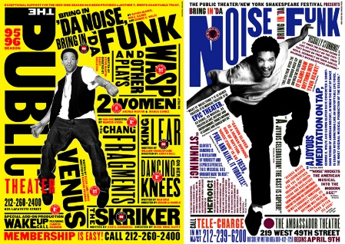 | Workshops:Tues p2, Thurs 1.20pm lunch.  Open Studios: see timetable on doors for free rooms to work.  Lunchtimes: supervised open studios Mon-Fri.  Enrichment: 360- Y2 HE Portfolio Development Fridays, 2 sessions in D101 & D103.
5 | 23 | Jamie Reid project Ransom note postcards  Peer Critique session  Lessons:​​​​​​​CREATIVE BRIEF :Design two postcards SIZE: 130x20mm to be sold using phrases connected to your own chosen theme set in the torn letter style of Reid, pasted onto a background image from your own photographs.  DIMENSIONS: 160x120mm LANDSCAPE RESOLUTION: 300 PIXELS/INCH  Create an A3 page of at least 4 thumbnail rough drawings of the layout/alternative ideas of your background photographs chosen and alternative position of the typography to suit the image. Present for homework below.  IMPORTANT: use real, actual torn-out letters from magazines and newspapers for the best effect. | Reid evalution from peer comments  Homework:  Critical study: Jamie Reid. ​Choose 3 examples of Reid's 'ransom note' work.WITHOUT PASTING INFORMATION FROM THE INTERNET write around 500 of YOUR OWN WORDS (word processed - consider the 'look' ie.typeface & size) about Reid and his work, considering the following points:  Who is he? (a 'mugshot' of the artist is always welcome)  What does he do?  When was his work most popular & what was happening  in the UK ​​​​​​​and the world at that time?  Do you like his work? If not, state why.  For each image you chose, consider these points:  - Why has the piece been created?  - Who is the target audience, and do you think it is appropriate for them?  - How do you think it was made?  - How does it make you feel - is it beautiful/eyecatching/alarming in any way?  - Why did you choose to include this particular piece in your critical study?  - Why did you choose to include this particular piece in your critical study?  Present the rough thumbnails and collage letter phrases on an A3 sheet.  Present the 2 final postcards on an A3 sheet; these can be digitally or manually constructed.  ​​​​​​​ | Resources available in D101 & PC and Printer  Magazines & newspapers first hand photos written materials art supplies card paper photocopied images  Additional PRESENTATIONS  *Available on Sharepoint |  | Paper cut out effect https://www.youtube.com/watch?v=Y75J5LE5iR0&list=PLflr3EiTAEy6CTcjUd_TGMeqPmbig8-qa   | Workshops:Tues p2, Thurs 1.20pm lunch.  Open Studios: see timetable on doors for free rooms to work.  Lunchtimes: supervised open studios Mon-Fri.  Enrichment:360 Y2 HE Portfolio Development Fridays, 2 sessions in D101 & D103.
6 | 30 | Jamie Reid project Ransom note postcards  Peer Critique session  Lessons:​​​​​​​CREATIVE BRIEF :Design two postcards SIZE: 130x20mm to be sold using phrases connected to your own chosen theme set in the torn letter style of Reid, pasted onto a background image from your own photographs.  DIMENSIONS: 160x120mm LANDSCAPE RESOLUTION: 300 PIXELS/INCH  Create an A3 page of at least 4 thumbnail rough drawings of the layout/alternative ideas of your background photographs chosen and alternative position of the typography to suit the image. Present for homework below.  IMPORTANT: use real, actual torn-out letters from magazines and newspapers for the best effect. | Reid evalution from peer comments  Homework:  Critical study: Jamie Reid. ​Choose 3 examples of Reid's 'ransom note' work.WITHOUT PASTING INFORMATION FROM THE INTERNET write around 500 of YOUR OWN WORDS (word processed - consider the 'look' ie.typeface & size) about Reid and his work, considering the following points:  Who is he? (a 'mugshot' of the artist is always welcome)  What does he do?  When was his work most popular & what was happening  in the UK ​​​​​​​and the world at that time?  Do you like his work? If not, state why.  For each image you chose, consider these points:  - Why has the piece been created?  - Who is the target audience, and do you think it is appropriate for them?  - How do you think it was made?  - How does it make you feel - is it beautiful/eyecatching/alarming in any way?  - Why did you choose to include this particular piece in your critical study?  - Why did you choose to include this particular piece in your critical study?  Present the rough thumbnails and collage letter phrases on an A3 sheet.  Present the 2 final postcards on an A3 sheet; these can be digitally or manually constructed.  ​​​​​​​ | Resources available in D101 & PC and Printer  Magazines & newspapers first hand photos written materials art supplies card paper photocopied images  Additional PRESENTATIONS  *Available on Sharepoint |  | Blend text into photos realistically https://www.youtube.com/shorts/_N-Hyu1FzlY   | Workshops:Tues p2, Thurs 1.20pm lunch.  Open Studios: see timetable on doors for free rooms to work.  Lunchtimes: supervised open studios Mon-Fri.  Enrichment: 360 Y2 HE Portfolio Development Fridays, 2 sessions in D101 & D103.
7 | Oct 7 | TYPOGRAPHIC ALBUM TASK  Lessons: Practical TASK  Present typographic interpretations of these 10 moods/feelings on an A3 page:  angry, sad, happy, romantic, tired, energetic, confused, bored, excited, sleepy.  Caption each word with the font name and point size, think about colour, size, format etc. | Homework: present both the following research on an A3 page:  Research the Ikea - House or Home text-based TV commercial on YouTube. Print screen grabs of favourite scenes and give your personal opinion on the creative use of type in this advert. Alternatively you may wish to research the Channel 4: Stand Up To Cancer commercial.  Critical study: Neville Brody https://www.pinterest.com/delamente/neville-brody-design/ Choose 3 examples of Brody's creative typography work.  WITHOUT PASTING INFORMATION FROM THE INTERNET  write around 500 of YOUR OWN WORDS  (word processed - consider the 'look' ie.typeface & size) about Brody  and his work, considering the following points:  Who is he? (a 'mugshot' of the artist is always welcome)  What does he do?  When was his work most popular & what was happening  in the UK ​​​​​​​and the world at that time?  Do you like his work? If not, state why.  For each image you chose, consider these points:  - Why has the piece been created?  - Who is the target audience, and do you think it is appropriate for them?  - How do you think it was made?  - How does it make you feel - is it beautiful/eyecatching/alarming in any way?  - Why did you choose to include this particular piece in your critical study? | Resources available in D101 & PC and Printer  Magazines & newspapers first hand photos written materials art supplies card paper photocopied images  Additional PRESENTATIONS  *Available on Sharepoint |  | Absolute essentials for any typography student  https://www.youtube.com/watch?v=Z8DehBmFqLc    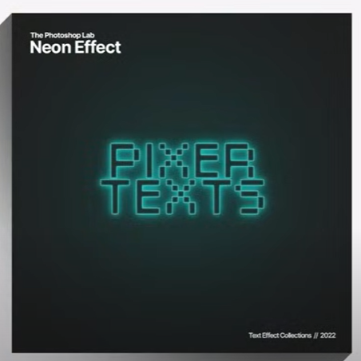 | Workshops:Tues p2, Thurs 1.20pm lunch.  Open Studios: see timetable on doors for free rooms to work.  Lunchtimes: supervised open studios Mon-Fri.  Enrichment: Drop-in: Fridays 12.15pm: Y1&2 Careers advice, portfolios, interview practice.  Trip: Leonardslee Gardens with Surrey Sculpture Society, see Share Point for details.
8 & 9 | 14 & 21 | Lessons: and Homework  Design and create album cover - Music chosen must tie in with your chosen theme.  Incorporate - own drawings, paintings - photographs,  *All sources to be first-hand or a written reason why not to the examiner with the image and source you have used for reference (NOT COPIED). eg if you need an image of a shark for Jaws!  Follow the design process on sharepoint  A3 page 1: brainstorm – moodboard – your own photographs  A3 page 2: Alternative thumbnail ideas - Best idea thumbnails - location of text - text experiments  A 3 page 3: Refined thumbnail design for front & back of album cover. Annotated compostional choices for the image & text  A 3 page 4: Present the final front and back of the design, square format.  *Extension: add the circular design for the CD or vinyl centre. |  | Resources available in D101 & PC and Printer  Magazines & newspapers first hand photos written materials art supplies card paper photocopied images  Additional PRESENTATIONS  *Available on Sharepoint |  | Shadow effects 6 approaches  https://www.youtube.com/watch?v=6pAGsTMqJD0      My life in typefaces - Matthew Carter  Pick up a book, magazine or screen, and more than likely you'll come across some typography designed by Matthew Carter. In this charming talk, the man behind typefaces such as Verdana, Georgia and Bell Centennial (designed just for phone books — remember them?), takes us on a spin through a career focused on the very last pixel of each letter of a font.  https://youtu.be/xjxyEwjG2Es | Workshops:Tues p2, Thurs 1.20pm lunch.  Open Studios: see timetable on doors for free rooms to work.  Lunchtimes: supervised open studios Mon-Fri.  Enrichment: Drop-in: Fridays 12.15pm: Y1&2 Careers advice, portfolios, interview practice.
 |  | HALF TERM
10 | Nov 4 | MONDAY INSET DAY  Lessons: Research: PATTERN  Take photographs of 6 objects connected to your theme  A3 research moodboard OF repeat patterns in graphic design: fabric, wallpaper, fashion, packaging, car design, logos etc. old and new.  A3 critical study into William Morris,MC Escher, Orla Kieley. in the format you have been taught (Brody). | Portfolio building  Homework:  New photographs of 10 single objects connected with your theme from college and home, preferably on a plain background if possible, eg.people, shoes, architecture details, tiles, food, cars, bicycles, bags, plants, flowers, jewellry etc.  Present on an A3 page. | Resources available in D101 & PC and Printer  Magazines & newspapers first hand photos written materials art supplies card paper photocopied images  Additional PRESENTATIONS  *Available on Sharepoint |  | Using advanced Photoshop for pattern  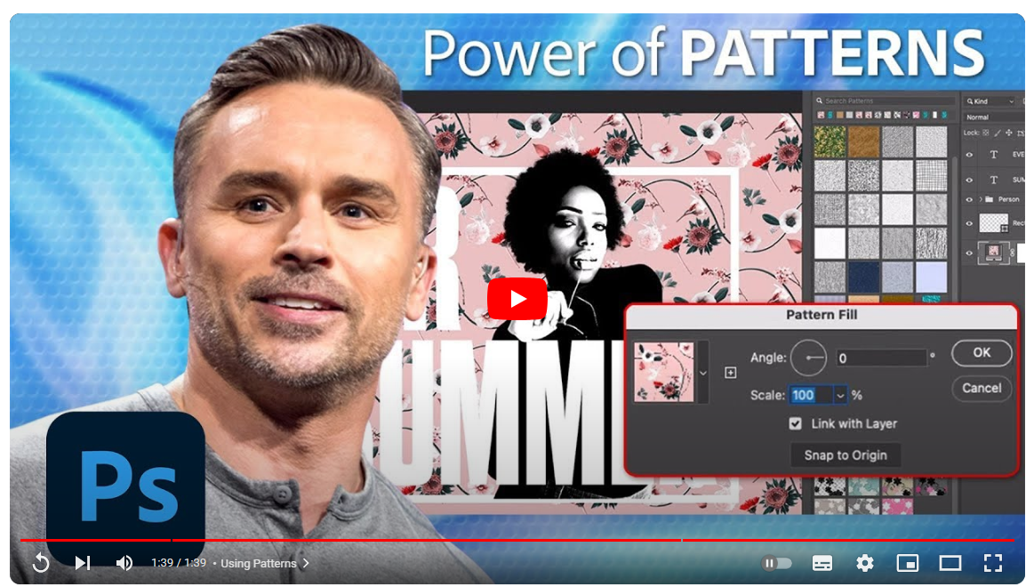  https://www.youtube.com/watch?v=s_H2v62FssI | Workshops:Tues p2, Thurs 1.20pm lunch.  Open Studios: see timetable on doors for free rooms to work.  Lunchtimes: supervised open studios Mon-Fri.  Enrichment: Drop-in: Fridays 12.15pm: Y1&2 Careers advice, portfolios, interview practice.
11 & 12 | 11 &18 | 13th 14th Open Evenings yr 10/11  14th Progress Review Day  15th Well being Day  Lessons and homework: Repeat Pattern experiments.  Look at colour in design using the Pantone Power Point. (Sharepoint)  Use single objects and pairings of objects to make increasingly complex generated repeat patterns  Show simple repeats but – mirrored - tesselated - overlaid patterns.  Show mulptiple colour swatch versions of each pattern.  Colours MUST suit intentions and the theme.  Use Power Points for reference when needed.  Present at least 4 patterns, increasing in complexity and colour choices on A3 sheets.  Extension: you could present as wrapping paper, wrap boxes, make matching tags, photoshop into interior design or fashion templates from the internet. | Lessons and homework: Repeat Pattern experiments.  Look at colour in design using the Pantone Power Point. (Sharepoint)  Use single objects and pairings of objects to make increasingly complex generated repeat patterns  Show simple repeats but – mirrored - tesselated - overlaid patterns.  Show mulptiple colour swatch versions of each pattern.  Colours MUST suit intentions and the theme.  Use Power Points for reference when needed.  Present at least 4 patterns, increasing in complexity and colour choices on A3 sheets.  Extension: you could present as wrapping paper, wrap boxes, make matching tags, photoshop into interior design or fashion templates from the internet. | Resources available in D101 & PC and Printer  Magazines & newspapers first hand photos written materials art supplies card paper photocopied images  Additional PRESENTATIONS  *Available on Sharepoint |  | Making Patterns in Photoshop  https://www.youtube.com/watch?v=HczImotdeEk  with Lemon Paper Lab  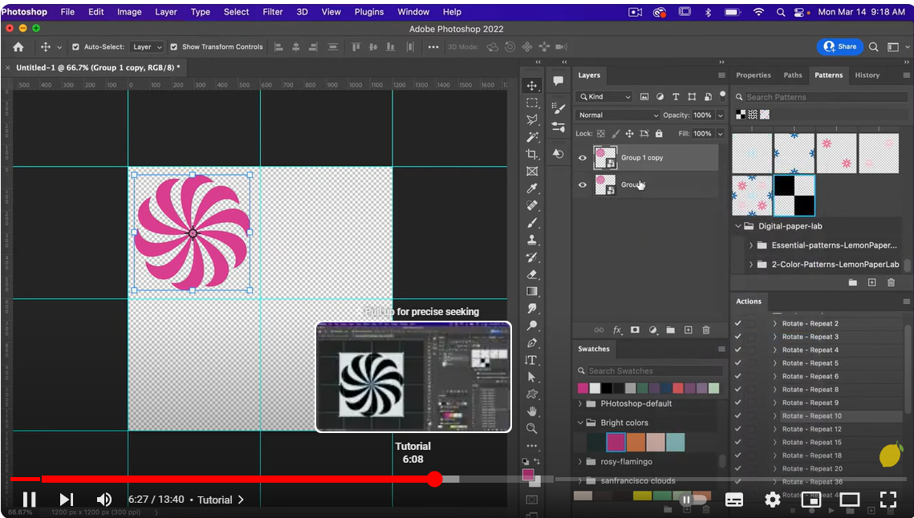  Making patterns in easy steps with PHLEARN  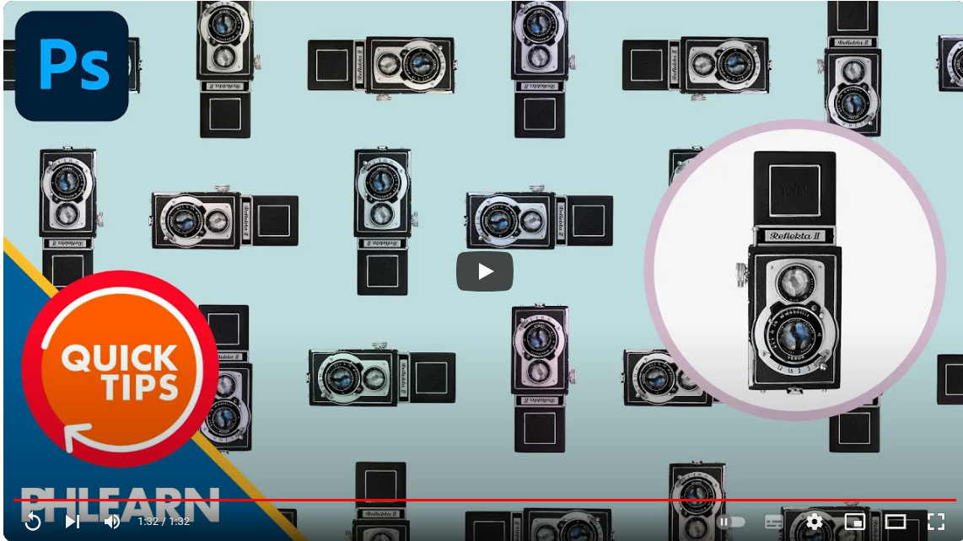  https://www.youtube.com/watch?v=ZiIfg4OZAnA | Workshops:Tues p2, Thurs 1.20pm lunch.  Open Studios: see timetable on doors for free rooms to work.  Lunchtimes: supervised open studios Mon-Fri.  Enrichment: Drop-in: Fridays 12.15pm: Y1&2 Careers advice, portfolios, interview practice.
13 to 16 | 25 Nov  To  16th Dec | LESSONS: Design Brief: 4 co-ordinated stamps  A3 sheet 1:researching at least 6 British and overseas pictoral stamp collections.- Annotate your selections.  A3 sheet 2: 6+ thumbnail sketches - possible stamp ideas - first hand images, patterns of yours that you will use.  A3 sheet 3: refine idea: - choose best idea - add thumbnail ideas of how the set of 4 - Change and experiment with images, composition - typography. Annotate compositional choices.  A3 sheet 3: add alternative typographic choices; styles of font,colour, sizes, position on each stamp - how the design of all 4 works together as a coherent group.  Check the size and proportion the final stamps should be.  A3 sheet 4: experiment and design with what media the stamp images will be; eg. Photoshop,Illustrator, Procreate, watercolour, coloured pencil, collage, acrylic paint etc. Add any newly generated patterns you may want to use.  A3 sheet 5: Add screenshots/photos of the making of the stamps and document their creation on this sheet.  A3 sheet 6: present the final stamps larger size and actual stamp size. | LESSONS: Design Brief: 4 co-ordinated stamps  A3 sheet 1:researching at least 6 British and overseas pictoral stamp collections.- Annotate your selections.  A3 sheet 2: 6+ thumbnail sketches - possible stamp ideas - first hand images, patterns of yours that you will use.  A3 sheet 3: refine idea: - choose best idea - add thumbnail ideas of how the set of 4 - Change and experiment with images, composition - typography. Annotate compositional choices.  A3 sheet 3: add alternative typographic choices; styles of font,colour, sizes, position on each stamp - how the design of all 4 works together as a coherent group.  Check the size and proportion the final stamps should be.  A3 sheet 4: experiment and design with what media the stamp images will be; eg. Photoshop,Illustrator, Procreate, watercolour, coloured pencil, collage, acrylic paint etc. Add any newly generated patterns you may want to use.  A3 sheet 5: Add screenshots/photos of the making of the stamps and document their creation on this sheet.  A3 sheet 6: present the final stamps larger size and actual stamp size. | Resources available in D101 & PC and Printer  Magazines & newspapers first hand photos written materials art supplies card paper photocopied images  Additional PRESENTATIONS  *Available on Sharepoint |  | Four Stamp artist speak about their work and stamps in general!  https://www.youtube.com/watch?v=PCgra1HvglI    How to make a stamp in Photoshop!  https://www.youtube.com/watch?v=-5_GOwmniXw  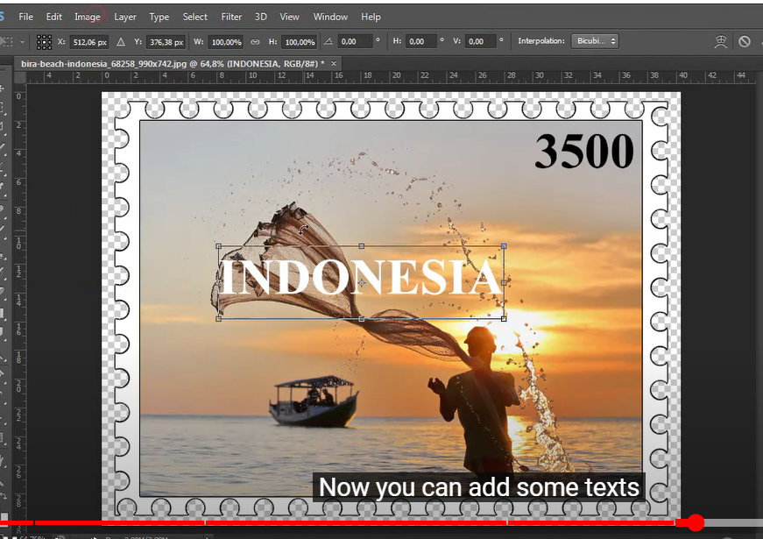  An interview with David Gentleman on his stamp design and the process.  https://www.youtube.com/watch?v=sNolr5QGp4Y  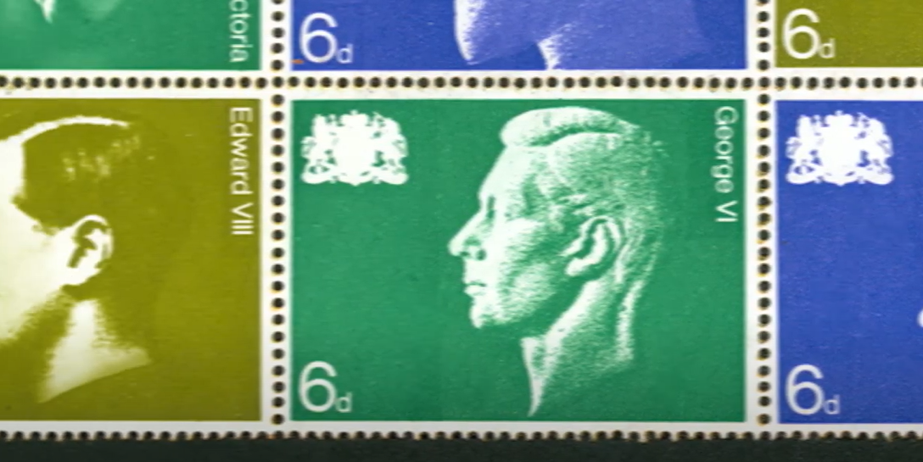 | Workshops:Tues p2, Thurs 1.20pm lunch.  Open Studios: see timetable on doors for free rooms to work.  Lunchtimes: supervised open studios Mon-Fri.  Enrichment: Drop-in: Fridays 12.15pm: Y1&2 Careers advice, portfolios, interview practice.
 |  | END OF TERM
17 | Jan 6 | LESSON TAROT CARDS  Design brief: to use cut paper drawing technique to create 2 tarot cards with imagery which relates to your theme and uses your photographs for the cut paper illustration work.  Lessons & homework:  A3 page moodboards research of tarot card and alternative card designs both traditional and contemporary.  A3 page research of paper-cut artists Rob Ryan and Peter Callasen:  Who is he? (a 'mugshot' of the artist is always welcome)  What does he do?  When was his work most popular & what was happening  in the UK ​​​​​​​and the world at that time?  Do you like his work? If not, state why.  For each image you chose, consider these points:  Why has the piece been created?  Who is the target audience, and do you think it is appropriate for them?  How do you think it was made?  How does it make you feel - is it beautiful/eyecatching/alarming in any way?  Why did you choose to include this particular piece in your critical study?  Why did you choose to include this particular piece in your critical study? | Lessons & homework:  A3 page moodboards research of tarot card and alternative card designs both traditional and contemporary.  A3 page research of paper-cut artists Rob Ryan and Peter Callasen:  Who is he? (a 'mugshot' of the artist is always welcome)  What does he do?  When was his work most popular & what was happening  in the UK ​​​​​​​and the world at that time?  Do you like his work? If not, state why.  For each image you chose, consider these points:  Why has the piece been created?  Who is the target audience, and do you think it is appropriate for them?  How do you think it was made?  How does it make you feel - is it beautiful/eyecatching/alarming in any way?  Why did you choose to include this particular piece in your critical study?  Why did you choose to include this particular piece in your critical study? | Resources available in D101 & PC and Printer  Magazines & newspapers first hand photos written materials art supplies card paper photocopied images  Additional PRESENTATIONS  *Available on Sharepoint |  | Intricate beauty by design - Marian Bantjes    In graphic design, Marian Bantjes says, throwing your individuality into a project is heresy. She explains how she built her career doing just that, bringing her delicate signature illustrations to storefronts, valentines and even genetic diagrams.  https://youtu.be/MkS-u32xfGc | Workshops:Tues p2, Thurs 1.20pm lunch.  Open Studios: see timetable on doors for free rooms to work.  Lunchtimes: supervised open studios Mon-Fri.  Enrichment: Drop-in: Fridays 12.15pm: Y1&2 Careers advice, portfolios, interview practice.
18 | 13 | Tues: Progress Review Day-no lessons  Lessons: A3 page:  At least 6 thumbnail designs of alternative cards. use the student example as a reference.  Add colour schemes, black & white, limited colour, swatchs etc. Test hand-painted paper and textures instead of simple coloured paper. also consider patterned wallpapers.  Homework: add final drawn refined 2 designs with typography in full colour scheme. | Lessons: A3 page:  At least 6 thumbnail designs of alternative cards. use the student example as a reference.  Add colour schemes, black & white, limited colour, swatchs etc. Test hand-painted paper and textures instead of simple coloured paper. also consider patterned wallpapers.  Homework: add final drawn refined 2 designs with typography in full colour scheme. | Resources available in D101 & PC and Printer  Magazines & newspapers first hand photos written materials art supplies card paper photocopied images  Additional PRESENTATIONS  *Available on Sharepoint |  | How artist Jazz Moe creates her card deck in illustrator  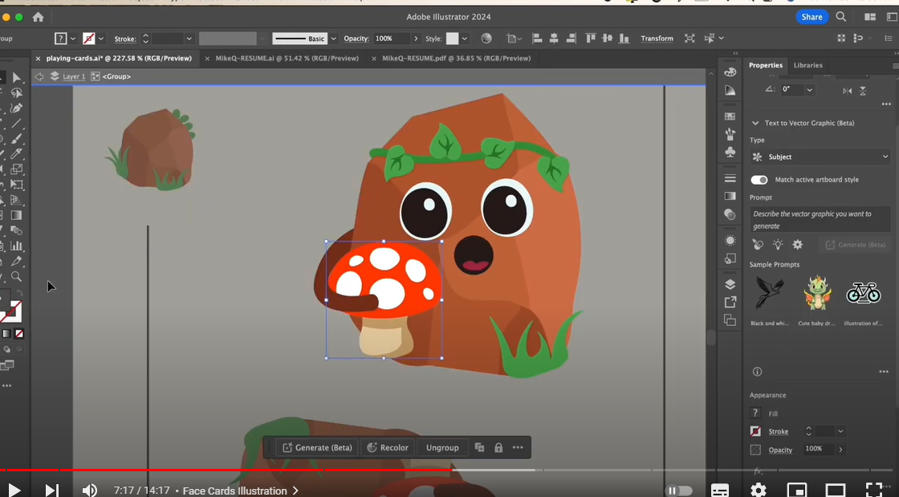  https://www.youtube.com/watch?v=DBK2va_RRYw | Workshops:Tues p2, Thurs 1.20pm lunch.  Open Studios: see timetable on doors for free rooms to work.  Lunchtimes: supervised open studios Mon-Fri.  Enrichment: Drop-in: Fridays 12.15pm: Careers advice, portfolios, interview practice.
19, 20, 21, 22 | Jan 20  To Feb 25th | Lessons and homework:  - Make the 2 cards in full colour scheme using cut paper - pay CLOSE attension to size and proportion of cards.  - Digitise, refine on Photoshop.  - Design back for the pack of cards. | Lessons and homework:  - Make the 2 cards in full colour scheme using cut paper - pay CLOSE attension to size and proportion of cards.  - Digitise, refine on Photoshop.  - Design back for the pack of cards. | Resources available in D101 & PC and Printer  Magazines & newspapers first hand photos written materials art supplies card paper photocopied images  Additional PRESENTATIONS  *Available on Sharepoint |  |   Carved stone effect  https://www.youtube.com/watch?v=hwRwUeVoFTo  Carved type into a patterned surface    https://www.youtube.com/watch?v=kt_Rknvc1H0 | Workshops:Tues p2, Thurs 1.20pm lunch.  Open Studios: see timetable on doors for free rooms to work.  Lunchtimes: supervised open studios Mon-Fri.  Enrichment: Drop-in: Fridays 12.15pm: Y1&2 Careers advice, portfolios, interview practice.
 |  | HALF TERM
23 | 24 | MONDAY INSET DAY  Lessons: MINIMILIST PORTRAIT  - Research the following artists: Julian Opie, Coco Davez, Noma Bar.  Who is he/she/they? (a 'mugshot' of the artist is always welcome)  What do they do?  When was their work most popular & what was happening  in the UK ​​​​​​​and the world at that time?  Do you like their work? If not, state why.  For each image you chose, consider these points:  - Why has the piece been created?  - Who is the target audience, and do you think it is appropriate for them?  - How do you think it was made?  - How does it make you feel - is it beautiful/eyecatching/alarming in any way?  - Why did you choose to include this particular piece in your critical study?  - Why did you choose to include this particular piece in your critical study?  Homework: take a series of selfies that represent you as a designer. Choose different angles, views. Present on an A3 sheet and annotate which you would like to use for your front cover to your coursework. |  | Resources available in D101 & PC and Printer  Magazines & newspapers first hand photos written materials art supplies card paper photocopied images  Additional PRESENTATIONS  *Available on Sharepoint |  | Julian Opie tasks about Minilasim  https://youtu.be/VFs2ktSwM38 | Workshops:Tues p2, Thurs 1.20pm lunch.  Open Studios: see timetable on doors for free rooms to work.  Lunchtimes: supervised open studios Mon-Fri.  Enrichment: Drop-in: Fridays 12.15pm: Y1&2 Careers advice, portfolios, interview practice.
24 | Mar 3 to Mar 31 | Lessons and homework:  Make a 300dpi A3 blank image in Photoshop.  Paste your chosen photo into the page and experiment with different sizes and crops with the image.  Screen shot all options and paste into an A3 page documenting the whole making process and annotating your reasons for your decisions.  Make the image in Photoshop from tutorial from Amanda.  Experiment with colours and typography for name.  Show all altenative design decisions of colours, typography and progress using screenshots pasted into A3 sheets. | Make a 300dpi A3 blank image in Photoshop.  Paste your chosen photo into the page and experiment with different sizes and crops with the image.  Screen shot all options and paste into an A3 page documenting the whole making process and annotating your reasons for your decisions.  Make the image in Photoshop from tutorial from Amanda.  Experiment with colours and typography for name.  Show all altenative design decisions of colours, typography and progress using screenshots pasted into a3 sheets. | Resources available in D101 & PC and Printer  Magazines & newspapers first hand photos written materials art supplies card paper photocopied images  Additional PRESENTATIONS  *Available on Sharepoint |  | BASIC INTRODUCTION TO ILLUSTRATOR  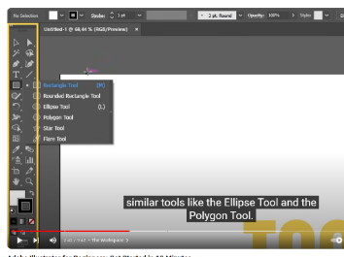  https://www.youtube.com/watch?v=3NBKRywEbNs  This is from the excellent Andy Tells Things youtube Chanel on you tube very much worth using  Using the pencil  https://www.youtube.com/watch?v=Rk-JGsriJ4o&list=RDCMUCxFvHi1W58pQqCciT08hGUA&index=3  Every Tool explained  https://www.youtube.com/watch?v=iQWTSupSrko&list=RDCMUCxFvHi1W58pQqCciT08hGUA&index=6  50 things you should know in illustrator | Workshops:Tues p2, Thurs 1.20pm lunch.  Open Studios: see timetable on doors for free rooms to work.  Lunchtimes: supervised open studios Mon-Fri.  Enrichment: Drop-in: Fridays 12.15pm: Y1&2 Careers advice, portfolios, interview practice.
25 | 10 | To be Confirmed  Year 1 Transfer Exam:date tbc  Your Collyers Year 1 Transfer Exam for Graphic Communication is a 100% coursework submission from September 2023-April 2024.  All work from September-April 23rd is required for the exam, printed out and presented in your folder.  This includes your essay research task below but NOT the essay at this point.  This work will be marked A*-U grade and determine progressing through to Year 2 in Graphic Communication as well as being the primary source for your UCAS grade.  All work must be fully submitted in your A2 folder/s and any animations etc on attached memory stick stuck onto the front of your folder. Animations must be in MP4 format.  Note: this is the formal Collyers Year 1 Graphics exam, any student not submitting the work required by 4.15pm on set date will fail the exam. Illness must be confirmed with a Doctors note or make arrangements for parents/friend to drop work into reception. EAAs are not applicable to practical exams. | To be Confirmed  Year 1 Transfer Exam:date tbc  Your Collyers Year 1 Transfer Exam for Graphic Communication is a 100% coursework submission from September 2023-April 2024.  All work from September-April 23rd is required for the exam, printed out and presented in your folder.  This includes your essay research task below but NOT the essay at this point.  This work will be marked A*-U grade and determine progressing through to Year 2 in Graphic Communication as well as being the primary source for your UCAS grade.  All work must be fully submitted in your A2 folder/s and any animations etc on attached memory stick stuck onto the front of your folder. Animations must be in MP4 format.  Note: this is the formal Collyers Year 1 Graphics exam, any student not submitting the work required by 4.15pm on set date will fail the exam. Illness must be confirmed with a Doctors note or make arrangements for parents/friend to drop work into reception. EAAs are not applicable to practical exams. | Resources available in D101 & PC and Printer  Magazines & newspapers first hand photos written materials art supplies card paper photocopied images  Additional PRESENTATIONS  *Available on Sharepoint |  |  | Workshops:Tues p2, Thurs 1.20pm lunch.  Open Studios: see timetable on doors for free rooms to work.  Lunchtimes: supervised open studios Mon-Fri.  Enrichment: Drop-in: Fridays 12.15pm: Y1&2 Careers advice, portfolios, interview practice.
26 | 17 |  |  | Resources available in D101 & PC and Printer  Magazines & newspapers first hand photos written materials art supplies card paper photocopied images  Additional PRESENTATIONS  *Available on Sharepoint |  |  | Workshops:Tues p2, Thurs 1.20pm lunch.  Open Studios: see timetable on doors for free rooms to work.  Lunchtimes: supervised open studios Mon-Fri.  Enrichment: Drop-in: Fridays 12.15pm: Y1&2 Careers advice, portfolios, interview practice.
27 | 24 |  |  | Resources available in D101 & PC and Printer  Magazines & newspapers first hand photos written materials art supplies card paper photocopied images  Additional PRESENTATIONS  *Available on Sharepoint |  |  | Workshops:Tues p2, Thurs 1.20pm lunch.  Open Studios: see timetable on doors for free rooms to work.  Lunchtimes: supervised open studios Mon-Fri.  Enrichment: Drop-in: Fridays 12.15pm: Y1&2 Careers advice, portfolios, interview practice.
28 | 31 | Lessons and homework:  Print off and prepare entire A2 folder for the Transfer Exam.  Make sure you have acted on any feedback from amanda on your work over the year. | Lessons and homework:  Print off and prepare entire A2 folder for the Transfer Exam.  Make sure you have acted on any feedback from amanda on your work over the year. | Resources available in D101 & PC and Printer  Magazines & newspapers first hand photos written materials art supplies card paper photocopied images  Additional PRESENTATIONS  *Available on Sharepoint |  |  | Workshops:Tues p2, Thurs 1.20pm lunch.  Open Studios: see timetable on doors for free rooms to work.  Lunchtimes: supervised open studios Mon-Fri.  Enrichment: Drop-in: Fridays 12.15pm: Y1&2 Careers advice, portfolios, interview practice.
 |  | EASTER HOLIDAYS
29 | April22 | Complete the essay research and essay for hand-in after WEX week.  See Sharepoint for detail on this requirement | Complete the essay research and essay for hand-in after WEX week. | Resources available in D101 & PC and Printer  Magazines & newspapers first hand photos written materials art supplies card paper photocopied images  Additional PRESENTATIONS  *Available on Sharepoint |  |  | Workshops:Tues p2, Thurs 1.20pm lunch.  Open Studios: see timetable on doors for free rooms to work.  Lunchtimes: supervised open studios Mon-Fri.  Enrichment: Drop-in: Fridays 12.15pm: Y1&2 Careers advice, portfolios, interview practice.
30 | 28 | Stop-motion animation | Critical study into stop motion - sledgehammer | Resources available in D101 & PC and Printer  Magazines & newspapers first hand photos written materials art supplies card paper photocopied images  Additional PRESENTATIONS  *Available on Sharepoint |  |  | Workshops:Tues p2, Thurs 1.20pm lunch.  Open Studios: see timetable on doors for free rooms to work.  Lunchtimes: supervised open studios Mon-Fri.  Enrichment: Drop-in: Fridays 12.15pm: Y1&2 Careers advice, portfolios, interview practice.
31  ART EXAM PERIOD | May 5 | Mon: Bank Holiday  PRACTICAL A LEVEL ARTS EXAMS: ALL ROOMS.  Y1 online work. |  |  |  |  | Support during practical exam period: email  Susie: sem@collyers.ac.uk or  Ian: IM@collyers.ac.uk or  Amanda: AH@collyers.ac.uk.
32 | 12 | PRACTICAL A LEVEL ARTS EXAMS: ALL ROOMS.  Y1 online work. |  |  |  |  | Support during practical exam period: email  Susie: sem@collyers.ac.uk or  Ian: IM@collyers.ac.uk or  Amanda: AH@collyers.ac.uk.
33 | 19 | College Study Leave Y1&Y2 |  |  |  |  | Support during practical exam period: email  Susie: sem@collyers.ac.uk or  Ian: IM@collyers.ac.uk or  Amanda: AH@collyers.ac.uk.
 |  | HALF TERM
34  WEX | Jun 2 | WEX WEEK
35 | 9 | Personal Investigation (written) | Research for investigation | Resources available in D101 & PC and Printer  Magazines & newspapers first hand photos written materials art supplies card paper photocopied images  Additional PRESENTATIONS  *Available on Sharepoint |  |  | Workshops:Tues p2, Thurs 1.20pm lunch.  Open Studios: see timetable on doors for free rooms to work.  Lunchtimes: supervised open studios Mon-Fri.  Enrichment:360 Y1 HE Portfolio Development Fridays, 2 sessions in D101 & D103.
36 | 16 | Tues: 1A-2A Progression Day  Personal Investigation (written) | Research for investigation | Resources available in D101 & PC and Printer  Magazines & newspapers first hand photos written materials art supplies card paper photocopied images  Additional PRESENTATIONS  *Available on Sharepoint |  |  | .Workshops:Tues p2, Thurs 1.20pm lunch.  Open Studios: see timetable on doors for free rooms to work.  Lunchtimes: supervised open studios Mon-Fri.  Enrichment:360 Y1 HE Portfolio Development Fridays, 2 sessions in D101 & D103.  Trip: free trip -UCA Farnham Degree Shows, tours, course lectures.
37 | 23 | Thurs:Festival of Arts  Personal Investigation (written) | Research for investigation | Resources available in D101 & PC and Printer  Magazines & newspapers first hand photos written materials art supplies card paper photocopied images  Additional PRESENTATIONS  *Available on Sharepoint |  |  | Workshops:Tues p2, Thurs 1.20pm lunch.  Open Studios: see timetable on doors for free rooms to work.  Lunchtimes: supervised open studios Mon-Fri.  Enrichment:360 Y1 HE Portfolio Development Fridays, 2 sessions in D101 & D103.  Festival of the Arts, June 27: careers talks & worksops + HE Arts fair.
38 | 30 | Mon: Welcome Day  Tues: Welcome Day  Personal Investigation (written) | Research for investigation | Resources available in D101 & PC and Printer  Magazines & newspapers first hand photos written materials art supplies card paper photocopied images  Additional PRESENTATIONS  *Available on Sharepoint |  |  | Workshops:Tues p2, Thurs 1.20pm lunch.  Open Studios: see timetable on doors for free rooms to work.  Lunchtimes: supervised open studios Mon-Fri.  Enrichment:360 Y1 HE Portfolio Development Fridays, 2 sessions in D101 & D103.  Trip: New Designers, Islington: Thurs July 3: Textiles, Jewelry, Ceramics, Glass,Fine Art, Photography.
39 | July 7 | Thurs 1.20pm Term ends for students.  Thurs: Y10 Open evening. |  |  |  |  | Workshops:Tues p2.  Open Studios: see timetable on doors for free rooms to work.  Lunchtimes: supervised open studios Mon-Thurs.  Trip: New Designers, Islington: Thurs July 10: Illustration, Animation, Games, DT.
40 | 14

FAQs: (frequently asked questions)
What is ERB?  It is our Employer Representative Board for the Visual Arts.  - A panel of 3 employers who engage with our subject annually to provide us with information about progression routes in their industry.  - They help us to understand the skills and qualities employers look for when recruiting early careers candidates (post-18 employment, apprenticeships and graduate level jobs).  - Engagement with local and national employers helps teachers to understand how knowledge and skills developed within the subject supports your progression into the world of work.  Who are our Visual Arts Employer Links?  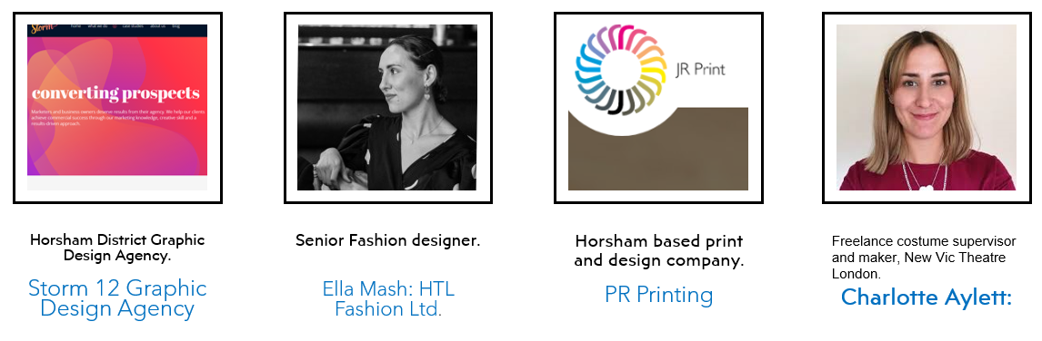 | What are the key messages employers have told us in the visual arts?  - RESEARCH: Strong, advanced research skills with genuine curiosity for the industry itself.  - COLLABORATION: The ability to openly collaborate , have good communication skills both verbally & digitally.  - PRACTICAL SKILLS: Strong prior learning in basic art & design skills but a willingness to adapt & learn new industry specific skills.  How do we promote these skills & values in our subject?  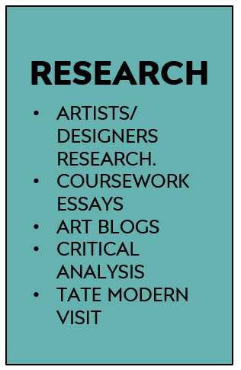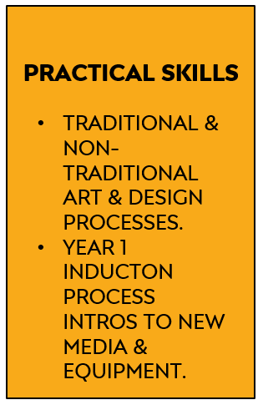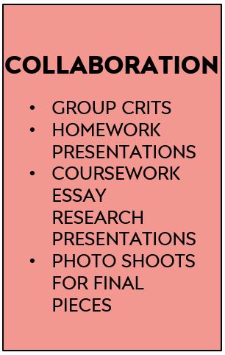  ERB 1 ERB 2 ERB 3
What do the Progress Review sections mean on this course?
- Progress Reviews in the A Level Art Department: for the purposes of self-assessment and teacher assessment, progress reviews are divided into:
- Performance grades: Performance Grades - A*-E for A Levels Year 2. Target (expected grade based on prior GCSEs). Current (grade you are currently working at. Estimated (an estimate of the grade you should realistically be able to achieve at the end of the course).
- Studentship grades: Studentship Grades - 1= outstanding, 2= good, 3= requires improvement, 4= serious cause for concern.
- Effort (commitment to study) - Hours per week of independent study per subject including:Teacher directed study – blog, life-drawing, homework tasks, coursework. Student directed study – consolidating learning, research or reading, skills practice, taking extra first-hand photos.
- Systems (organisation of study) Time Management - punctuality, completing planned study, completing homeworks, meeting deadlines. Organisation - bringing relevant equipment, sketchbooks, organisation of annotations, having work printed-out/presented on time.
- Practice (study behaviours) In class – full participation in lessons e.g. engaged listening, asking questions, contributing to discussion, using practical time well. Independent Study – practising skills as well as consolidating knowledge, , use of subject VLE, Pinterest, artists/designers blogs, visiting exhibitions & museums. Taking responsibility for learning – addressing problems, seeking help, using feedback constructively, attending subject workshops, identifying and avoiding distractions/barriers to learning.
- Attendance: Attendance - Percentage of classes attended in period. Punctuality - Percentage of classes attended on time in period.

How can I improve my progress in this subject?  A Level studentship can be easily improved by paying attention to the following points across all endorsements:  - Excellent attendance and punctuality; vital in practical subjects.  - Careful reading of this course’s Share Point each week to be clear of weekly tasks and use given resources to guide your work.  - If you miss a lesson for a valid reason; check Share Point to be prepared for the next lesson you attend; read the set work and watch any Power Points, videos used in class.  - Book-craft is very important:it includes quality titles, layout, annotation of work.  - Considered choices of artists and strong personal responses. |  | - Thoughtful Rod Taylor analysis of work using specialist vocabulary, see glossary on Share Point.  - Strong artists research from multiple sources.  - Handing all work in on time to allow for adequate verbal feedback and participate meaningfully in group crits of homeworks and final pieces.  - Act upon your feedback from your teacher.  - Attending workshops when you need extra 1-1 help on class or homeworks.
What methods do we use for assessment on the course?  Examples of some formative assessment methods we use every day in the Art Department:  - Establishing success criteria for the lesson, task, homework or section of coursework.  - Use of targeted closed questions exploring levels of understanding  - Use of open questioning to extend learning  - Self assessment/reflection  - Peer assessment  - Use of response partners/ small group  - Use of mini-plenaries during the lesson. |  | Examples of summative assessments we also use at specific times of the academic year:  - A final artifact for coursework - a print, drawing, painting, garment, textiles piece, digital piece.  - Year 2 exam sketchbook  - Year 2 exam 15 hour final exam piece.  - Year 1 Transfer Exam submission.  - A final essay – the 1000 word coursework essay.  - A component submission - the coursework or the exam unit.
What feedback do we use on the course?  Critiques (crits)  - Group homework crits each week or at key homework points.  - Lots of different formats from individually showing work to laying books in table for discussion.  - Final piece crits at the end of a final piece.  Use of Exemplar work in the class-room:  - Group discussion of excellent homeworks for inspiration.  - Group discussions of excellent processes, eg printmaking, dye samples etc.  - Share Point exemplar Power Points.  - Pinterest examples on Susie’s site. |  | Others:  - 1-1s with staff formally & informally in class.  - Post-it notes in sketchbooks for improvement suggestions.  - Teams feedback for Graphics.  - Year 1 Transfer Feedback sheet with actions.
How does the work support the Collyers Policy on British Values?  - The selection of artists, designers and makers complies and acknowledges the precepts identified by the  college clearly in both Pro Study and the core curriculum; Democracy,The rule of Law,Individual liberty,  Mutual Respect,Tolerance of different faiths and beliefs. |  | 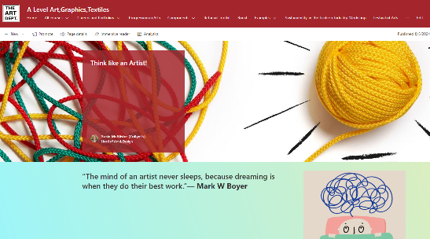  It is an essential part of your growth as an artist to understand what factors can drive individual creativity,  see the Think Like an Artist section on Share Point.

