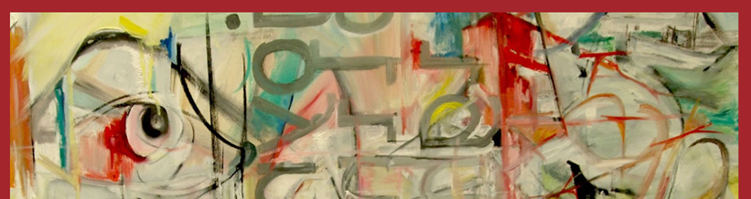 |  |  |  |  |  | ART DEPARTMENT SCHEME OF WORK for staff & students.
 |  |  |  |  |  | Course: A Level Graphic Communication
 |  |  |  |  |  | Year Group: Year 2
 |  |  |  |  |  | Teachers: Ian McAlister.
EDUQAS Assessment Objectives for this course are:  AO1 Contextual Understanding 25%. Develop ideas through sustained and focused investigations informed by contextual and other sources, demonstrating analytical and critical understanding.  AO2 Creative Making 25%. Explore and select appropriate resources, media, materials, techniques and processes, reviewing and refining ideas as work develops.  AO3 Reflective Recording 25%. Record ideas, observations and insights relevant to intentions, reflecting critically on work and progress.  AO4 Personal Presentation 25%. Present a personal and meaningful response that realises intentions and, where appropriate, makes connections between visual and other elements. |  |  |  |  | Our Employer Representative Board (see FAQs) for the Visual Arts recommendations help us to understand how knowledge and skills developed within the subject supports your progression into the world of work and link strongly with the EDUQAS AOs, as demonstrated in the first few weeks of the curriculum below.  ERB 1: Research: Strong, advanced research skills with genuine curiosity for the industry itself.  ERB 2: Practical skills: Strong prior learning in basic art & design skills but a willingness to adapt & learn new industry specific skills.  ERB 3: Collaboration: The ability to openly collaborate , have good communication skills both verbally & digitally.
Week | Date | A Level Course Class work: | A Level Course Homework (5 hours): | Resources available/needed: |  | Pro Study:  Designed to introduce a breadth of contemporary artists, designers or practices which help define arts place in society & inclusive, diverse creativity. | Curriculum support & breadth:  This section highlights the other areas of the wider Arts curriculum: to include workshops, open studios, enrichment, planned trips, talks, competitions week by week during the year.
3 | Sept 9 | Mock Exam  PLANNING  Lessons & homeworks:  - In Large folder: add heading of Personal Investigation.  - Add a printed-out photos that you have taken over th summer to support your investigation alongside any additional graphic material you have collected or recorded  - Brainstorm 1 page+ Using ideas from your summer collection and your previous work in your folder as a starting point, quotes, general references, internet/artists examples, your own ideas. Try to be thorough, inventive and think laterally.  - Thumbnails: 2 A3 pages+ of thumbnail sketches from ideas directly from your brainstorm and summer collection..  - Discuss your chosen mock idea with your teacher. | Completion of the work in class for the mock. | Files & visual examples on subject Share Point:  Year 2 format Power Point.  Previous student examples for the exam FMPs PP  Media experiments reminder PP.  Creative making suggestions Doc.  *Timesheet on Share Point to download and use for the Mock. |  | PRO-STUDY – GRAPHIC COMMUNICATION  Watch theses Ted Talks and make a ‘Blog’ review for each one that is presented inyour folder.  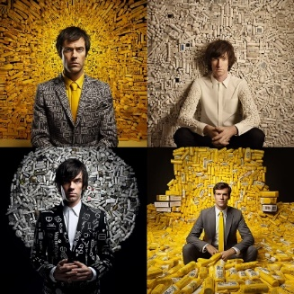  Designing with slogans - Stefan Sagmeister  WITTY – BRILLIANT – UNBELEIVABLE - IDEAS IN ACTION - PERFORMANCE TYPOGRAPHY  Amazing ideas designed and brought TO LIFE BY BRAVE PARTICIPATION  https://youtu.be/2OUFCyKr-t0 | Workshops:Tues p2, Thurs 1.20pm lunch.  Open Studios: see timetable on doors for free rooms to work.  Lunchtimes: supervised open studios Mon-Fri.  Enrichment: 360-Y2 HE Portfolio Development Fridays, 2 sessions in D101 & D103.
4 & 5 | 16+ 23 | Mock Exam  MAKING  Make the final piece/s using lessons and homework time up to 15 hours. Use the timesheet given to record your timings.  Photograph and document and three dimensional experiments use screen shots to explain photoshop manipulation of the progress of the final piece in your folder. | Completion of the mock FMP work in class, remember to keep time sheet up to date to onitor how you use the 15 hours.  Use examples shown on Sharepoint as a guide for how to lay out your folder and refer to students exemplar work powerpoints to understand requirements of project | Files & visual examples on subject Share Point:  Retreival Toolkit PP & videos for all media & processes.  Media experiments reminder PP.  Creative making suggestions Doc. |  | 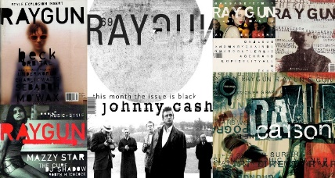  Design, discovery and humour - David Carson  Great design is a never-ending journey of discovery — for which it helps to pack a healthy sense of humour. Sociologist and surfer-turned-designer David Carson walks through a gorgeous (and often quite funny) slide deck of his work and found images.  https://youtu.be/tFpANOqSdi8  Your elusive creative genius - Elizabeth Gilbert  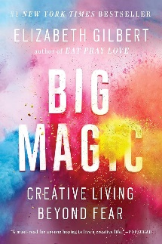  Elizabeth Gilbert muses on the impossible things we expect from artists and geniuses — and shares the radical idea that, instead of the rare person "being" a genius, all of us "have" a genius. It's a funny, personal and surprisingly moving talk.  https://www.youtube.com/watch?v=86x-u-tz0MA | Workshops:Tues p2, Thurs 1.20pm lunch.  Open Studios: see timetable on doors for free rooms to work.  Lunchtimes: supervised open studios Mon-Fri.  Enrichment: 360- Y2 HE Portfolio Development Fridays, 2 sessions in D101 & D103.
6 | 30 | Planning for FINAL MAJOR PROJECT  Brainstorm Use a combination of written ideas, thumbnail drawings, cuttings and internet images  Initial Thumbnails 2 A3 pages of initial thumbnails - inventive and varied to give you ideas for the project.  Review of ideas-Which excite  Refined thumbnails: 2 more A3 pages of ideas from your initial thumbnails you want to explore further. | Refined thumbnails: decide which ideas from initial thumbnails work and which to explore further.  Make exploratory sketches, colour studies to refine idea to a refined thumbnail proposal for your FMP.  Add any photos that are relevant from your summer collection, investigate alternative graphic sources cut paper drawn images tablet drawings, photoshop, illustrator, procreate, printmaking etc as examples of where the ideas have come from. | ON SHAREPOINT  POWERPOINT PRESENATION  Final Major Project explanation and Time line  Visual examples of task for Thumbnails  Brainstorming  Refined Thumbnails  Task Sheet to aid in development of Creative making with artist reference and planning included |  | 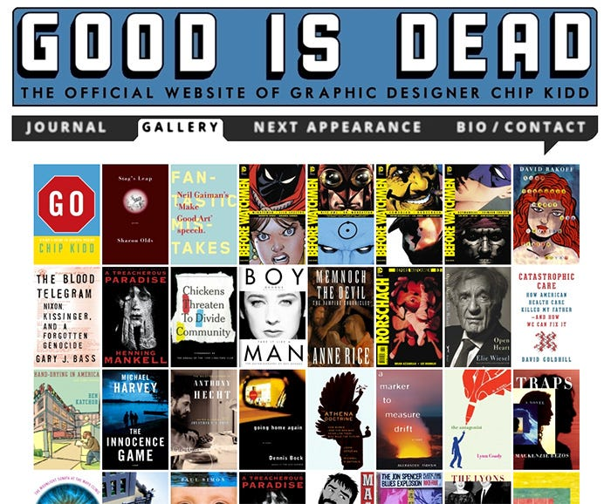  Designing books is no laughing matter. Chip Kidd  Chip Kidd doesn’t judge books by their cover, he creates covers that embody the book — and he does it with a wicked sense of humour. In one of the funniest talks from TED2012, he shows the art and deep thought of his cover designs. This talk is from The Design Studio session at TED2012, guest-curated by Chee Pearlman and David Rockwell.  https://youtu.be/cC0KxNeLp1E | Workshops:Tues p2, Thurs 1.20pm lunch.  Open Studios: see timetable on doors for free rooms to work.  Lunchtimes: supervised open studios Mon-Fri.  Enrichment: 360 Y2 HE Portfolio Development Fridays, 2 sessions in D101 & D103.
7 & 8 | Oct 7+  14 | FMP final plan:  Make a full folder double page plan ( 4 A3 of your final idea/s for the FMP. This should be an  enhanced thumbnail with notes on  *colour schemes  *compositional alternatives labelled with focal point use of directional planes, foreground, middleground, background etc.  *use of media.  Use the example below to inform your choices.  Content of any information used on graphic images etc.  Start the FMP (or small maquette/test piece if needed).  . | AO3 RECORD  Task: Using your first hand photos from the summer work or any additional you have taken to demonstrate your recording skills by producing responses to the following 4 formal elements of Design. You have homework for 2 weeks + Half Term to complete this work: 10 hours, with 8 hours of drawing below, 2 hours thinking time to work out what to do for each formal element. This needs to be QUALITY work, if you want to do it larger than your book then photograph it into the book as well:  Each response should take 2 hours and use at least one full page of your book. It should be a graphic response that uses the formal element  You should make at least four full pages of work  - LINE : Make a line drawing using more than one colour of line. This should be in detail you might like to explore using the colours to indicate foreground middle ground and background. Media = pen – coloured pencil – ink - acrylic -digital drawing  - SHAPE: Using blocks of colour develop a response that uses no line. Media = paint, collage, coloured pencil, pen, digital formats, photoshop, procreate.  - SPACE: Investigate the use of negative space by only using black to indicate negative space. Media = Pen, ink, marker, digital media, photoshop, procreate.  - TEXTURE: Replicate and explore a texture in paint, collage, digital, or any mixed media magic. Find ways to show texture, create texture or give the illusion of texture. For instance scratching into wet paint for fur or building up layers of tissue for close ups of skin. Media as appropriate. | Files & visual examples on subject Share Point:  PDF task visual examples and explanations for Formal Elements work.  PP AO3 recording examples for this task. |  | 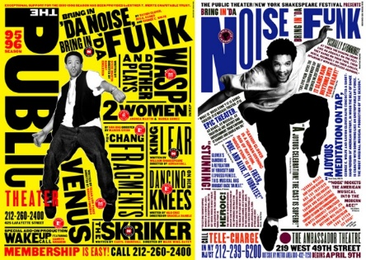  Great design is serious, not solemn - Paula Scher  Paula Scher looks back at a life in design (she's done album covers, books, the Citibank logo) and pinpoints the moment when she started having fun. Look for gorgeous designs and images from her legendary career.  https://youtu.be/atn22-bmTPU    My life in typefaces - Matthew Carter  Pick up a book, magazine or screen, and more than likely you'll come across some typography designed by Matthew Carter. In this charming talk, the man behind typefaces such as Verdana, Georgia and Bell Centennial (designed just for phone books — remember them?), takes us on a spin through a career focused on the very last pixel of each letter of a font.  https://youtu.be/xjxyEwjG2Es | Workshops:Tues p2, Thurs 1.20pm lunch.  Open Studios: see timetable on doors for free rooms to work.  Lunchtimes: supervised open studios Mon-Fri.  Enrichment: Drop-in: Fridays 12.15pm: Y1&2 Careers advice, portfolios, interview practice.  Trip: Leonardslee Gardens with Surrey Sculpture Society, see Share Point for details.
9 | 21 | FMP development in class, individual in its nature. This could be experimental maquettes, learning a new technique or media/technology or starting the actual final piece. | Lesson: FMP in class Homework: 6 hours, 2 double page minimum in sketchbook from task set below:  - Present any new photos needed for the FMP that are not in your folder, be thorough -this includes reference figures, portraits, trees, skies, buildings, details of things etc.  - Practice Drawings in any media, traditional or digital of any subject related to your FMP. These MUST be from your first-hand reference photos from your concertina or as above. You can only use second hand references from the internet for unusual things you could not reasonably photograph yourself eg. the moon, underwater submarines, tigers etc. These can only be photographs, not artists work. You must declare where these second hand images have come from eg. web addresses. | Files & visual examples on subject Share Point:  PDF task visual examples and explanations for Formal Elements work.  PP AO3 recording examples for this task. |  |   Intricate beauty by design - Marian Bantjes  In graphic design, Marian Bantjes says, throwing your individuality into a project is heresy. She explains how she built her career doing just that, bringing her delicate signature illustrations to storefronts, valentines and even genetic diagrams.  https://youtu.be/MkS-u32xfGc | Workshops:Tues p2, Thurs 1.20pm lunch.  Open Studios: see timetable on doors for free rooms to work.  Lunchtimes: supervised open studios Mon-Fri.  Enrichment: Drop-in: Fridays 12.15pm: Y1&2 Careers advice, portfolios, interview practice.  Competition:Design mural for new Common Room space, see Share Point for details.
 |  | HALF TERM
10 | Nov 4 | Monday: INSET DAY  FMP development in class, individual in its nature. This could be experimental maquettes, learning a new technique or media/technology or starting the actual final piece. | COLOUR A01&2  Lesson: FMP in class Homework: 6 hours, 2 double page minimum in sketchbook from task set below:  Find an artist's or designers image (painting, drawing, photography, digital, sculpture) which you really admire the colour scheme of (if black & white then the mark-making you like). Print off and present in your folder explaining why it inspires you for your FMP. Is it the atmosphere created? harmonising or clashing colours?  Make a chart of the colours used, presented in your own way. You can use magazine cuttings, paint, pens, pastel, collage, Photoshop, procreate etc to recreate the colours.  Create 3 alternative colour palettes for your own FMP. Present imaginatively and explain your choices: are they realistic, pop art, modern illustration, fashionable, traditional, futuristic, cold colours, pastels, warm colours, black & white, grey-scale...  Make a test of a small section of your FMP with these colours (in 2D, 3D or digital) | Share Point:  Pdf: See Visual example.  Retreival Toolkit.  Y1 share point previous exercise. |  | 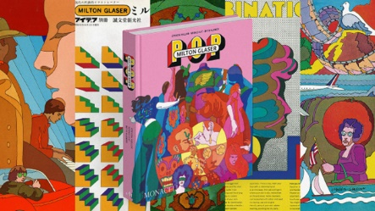  Using design to make ideas new - Milton Glaser  From the TED archives: The legendary  graphic designer Milton Glaser dives deep into a new painting inspired by Piero Della Francesca. From here, he muses on what makes a convincing poster, by breaking down an idea and making it unique. | Workshops:Tues p2, Thurs 1.20pm lunch.  Open Studios: see timetable on doors for free rooms to work.  Lunchtimes: supervised open studios Mon-Fri.  Enrichment: Drop-in: Fridays 12.15pm: Y1&2 Careers advice, portfolios, interview practice.
11 | 11 | FMP development in class, individual in its nature. This could be experimental maquettes, learning a new technique or media/technology or starting the actual final piece. | COMPOSITION AO1  Homework: 6 hours, 2 double page minimum in folder from task set below:  Choose and print-off a relevant piece of artists or designers work that inspires you when making your FMP, that can be because of the media, colours or subject matter.  Now label the following on the artist' image:  * focal point,  rule of 1/3ds, *foreground/middleground/  background,  *direction of light,  *picture planes - diagonals, horizontals & verticals.  Use the Graphic Composition and Why it Matters Power Point below from the sharepoint to help you breakdown this response | Share Point:  Composition PP  Rod Taylor questions sheet.  Pdf: Visual example of exercise. |  | 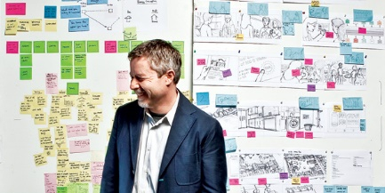  Designers – Think big! - Tim Brown  Tim Brown says the design profession has a more significant role to play than just creating nifty, fashionable little objects. He calls for a shift to local, collaborative, participatory "design thinking" — starting with the example of 19th-century design thinker Isambard Kingdom Brunel.  https://youtu.be/UAinLaT42xY | Workshops:Tues p2, Thurs 1.20pm lunch.  Open Studios: see timetable on doors for free rooms to work.  Lunchtimes: supervised open studios Mon-Fri.  Enrichment: Drop-in: Fridays 12.15pm: Y1&2 Careers advice, portfolios, interview practice.
12 | 18 | FMP development in class, individual in its nature. This could be experimental maquettes, learning a new technique or media/technology or starting the actual final piece. | DOCUMENTATION A01,AO2,AO4  At least 2 A3 pages in folder from task set below:  Fully documented FMP progress including photos and/or screen shots of the process of making the piece/s, any test pieces and discussing the problems you encountered, changes you made to make the piece work. This should be a full discussion with the examiner.  Print out or photo of the final piece (in progress) preseneted in folder and annotated fully with compositional notes as last week's excercise: eg*focal point, rule of 1/3ds, foreground /middleground/background, direction of light, picture planes - diagonals, horizontals & verticals. | Share Point:  Supporting Studies PP. |  | The beauty of data visualisation - David McCandless    David McCandless turns complex data sets (like worldwide military spending, media buzz, Facebook status updates) into beautiful, simple diagrams that tease out unseen patterns and connections. Good design, he suggests, is the best way to navigate information glut — and it may just change the way we see the world.  https://youtu.be/5Zg-C8AAIGg | Workshops:Tues p2, Thurs 1.20pm lunch.  Open Studios: see timetable on doors for free rooms to work.  Lunchtimes: supervised open studios Mon-Fri.  Enrichment: Drop-in: Fridays 12.15pm: Y1&2 Careers advice, portfolios, interview practice.
13+14 | 25+ Dec 2 | CREATIVE MAKING:  TASK: *Make: a minimum 4 quality experiments - Consider alternatives or additional directions for you FMP. Can you make flyers, book marks, wrapping paper, advertisements, animations? Can you theme ideas for additional products or designs, a clothing range, a childs version, an adults version, of your design.  This is the point where you discuss the possibilities that your work can go in, if you had unlimited time. This demonstrates that you have expored a number of avenues. These should be mock ideas that you can make (such as book covers wrapped around books or perhaps something that you have modelled in photoshop (your patterns as curtains or packaging etc) | Present in folder - it's the DOCUMENTATION that is important in these 2 weeks – demonstrating that you have considered a wide range of options colour schemes and possibilities for your design. Include any making information such as screen shots or larger three dimensional work.  Think about this as an extension of the formal elements exercises in the Week 5 homework, but more focusses on the possibilities of whatyou have created. | .Pdf Creative Making sheet.  Creative making examples PP.  Sketchbook page examples. |  | Design and the elastic mind - Paola Antonelli  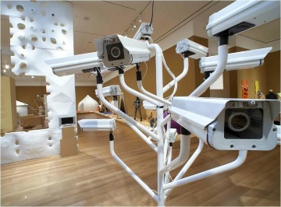  MOMA design curator Paola Antonelli previews the groundbreaking show Design and the Elastic Mind — full of products and designs that reflect the way we think now.  https://youtu.be/iNEGiPXhiAY | Workshops:Tues p2, Thurs 1.20pm lunch.  Open Studios: see timetable on doors for free rooms to work.  Lunchtimes: supervised open studios Mon-Fri.  Enrichment: Drop-in: Fridays 12.15pm: Y1&2 Careers advice, portfolios, interview practice.
15 | 9 | Lesson: FMP in class | FMP continuation |  |  | Continue building your Ted Talks or Tate Shots blog weekly but with artists, designers, craftspeople who specifically relate to your project/exam work. | Workshops:Tues p2, Thurs 1.20pm lunch.  Open Studios: see timetable on doors for free rooms to work.  Lunchtimes: supervised open studios Mon-Fri.  Enrichment: Drop-in: Fridays 12.15pm: Y1&2 Careers advice, portfolios, interview practice.  Trip: Tate Britain: Turner Prize and ‘Now you see Us’ -see Share Point for details.
16 | 16 | Wed: Term Ends.  FMP in class | Rewrite and present coursework final essay with any additional comment or observationas you might have now you are further into the project in folder.  Print-out and add final Pro Study blog entries into coursework sketchbook. | Share Point:  See all essay research and writing resources in Year 1Graphic or use the year two reminder section or the Retreival Toolkit on sharepoint. |  | Continue building your Ted Talks or Tate Shots blog weekly but with artists, designers, craftspeople who specifically relate to your project/exam work. | Workshops:Tues p2, Thurs 1.20pm lunch.  Open Studios: see timetable on doors for free rooms to work.  Lunchtimes: supervised open studios Mon-Fri.  Enrichment: Drop-in: Fridays 12.15pm: Y1&2 Careers advice, portfolios, interview practice.
 |  | END OF TERM
17 + 18 | Jan 6+ 13 | Lessons and homeworks: Two Weeks lessons and homeworks to complete FMPs and document in sketchbook. |  | Share Point:  Documentation PP in Retreival Toolkit. |  | Continue building your Ted Talks or Tate Shots blog weekly but with artists, designers, craftspeople who specifically relate to your project/exam work. | Workshops:Tues p2, Thurs 1.20pm lunch.  Open Studios: see timetable on doors for free rooms to work.  Lunchtimes: supervised open studios Mon-Fri.  Enrichment: Drop-in: Fridays 12.15pm: Y1&2 Careers advice, portfolios, interview practice.
19 | 20 | Lesson: FMP completion and then move onto homework documentation and connections task. | FINAL DOCUMENTATION & CONNECTIONS AO1&2,4.  Homework: 6 hours, 2 double page minimum in folder from task set below:  - 1 double page+ of fully documented FMP including photos and/or screen shots of the process of making the piece/s and discussing the problems you encountered, changes you made to make the piece work. This should be a full discussion with the examiner.  - Photo of final piece/s in sketchbook. And final images presented on board in glass envelopes for display as well.  - 1 double page making connections between your FMPs and the artists who have inspired you to make them. Use the Word Doc in this section or write/type freehand. | Share Point: Coursework Connections sheet to down load and complete. |  | Continue building your Ted Talks or Tate Shots blog weekly but with artists, designers, craftspeople who specifically relate to your project/exam work. | Workshops:Tues p2, Thurs 1.20pm lunch.  Open Studios: see timetable on doors for free rooms to work.  Lunchtimes: supervised open studios Mon-Fri.  Enrichment: Drop-in: Fridays 12.15pm: Y1&2 Careers advice, portfolios, interview practice.
20 | 27 | LEARNER STATEMENT:  Complete the Learner Statement typed or hand-written.  Complete all highlighted sections fully.  Print out the completed form and give to your teacher on submission of coursework. |  | Share Point:  Example completed Learner Statement for Component 1 Fine Art.  Blank Word Doc Learner Statement to download and complete. |  | Continue building your Ted Talks or Tate Shots blog weekly but with artists, designers, craftspeople who specifically relate to your project/exam work. | Workshops:Tues p2, Thurs 1.20pm lunch.  Open Studios: see timetable on doors for free rooms to work.  Lunchtimes: supervised open studios Mon-Fri.  Enrichment: Drop-in: Fridays 12.15pm: Y1&2 Careers advice, portfolios, interview practice.
21  Y2 EXAM | Feb 3 | EXAM:  Lessons: AO3 Record  Make at least 6 small scale collages of the theme word or words using found letters.  Make 4 Collages exploring the theme considering COLOUR COMPOSITION BALANCE within collage  These collages must include typography/letter/number forms. You can handcut letterforms and use photoshop but it must be manually built.  From this exploratory work make a final finished presentation image that can be used as a postage stamp or set of stamps. You may use Photoshop to generate this visual. | 6 HOURS Homework:  6 hours Homework Two A3 pages of research on typographic collage artists to include DAN FERN & MIMMO ROTELLA and at least 2 A3 Page of your own Artist/Designer choice work | Share Point resources:  Whole exam book layout and example page by page.  Stages of FMP PP.  1st 4 weeks of exam PP. |  | Continue building your Ted Talks or Tate Shots blog weekly but with artists, designers, craftspeople who specifically relate to your project/exam work.This will boost your AO1 & 3 marks for the exam. | Workshops:Tues p2, Thurs 1.20pm lunch.  Open Studios: see timetable on doors for free rooms to work.  Lunchtimes: supervised open studios Mon-Fri.  Enrichment: Drop-in: Fridays 12.15pm: Y1&2 Careers advice, portfolios, interview practice.
22 | Feb 10 | Lessons; O2 & 3 Exploring & Record:  Make a small relief or shadow box based upon your previous work. You may add additionally collected photographs on the theme ( add these to your planning) or additional collages or drawings. As this is a development in process of your first reaction to the paper. Make sure that you add thumbnail sketches of your ideas to the produce at least two A3 Pages of development of the box. | 6 HOURS Homework:  6 hours Homework: Three A3 pages of research on Paper artists to include SUE BLACKWELL, ROB RYAN, HARI & DEEPTI, and at least two A3 Pages of your own Artist/Designer choice work | Share Point resources:  Powerpoint presentation on shadow boxes links to artists you might find helpful. |  | Continue building your Ted Talks or Tate Shots blog weekly but with artists, designers, craftspeople who specifically relate to your project/exam work. | Workshops:Tues p2, Thurs 1.20pm lunch.  Open Studios: see timetable on doors for free rooms to work.  Lunchtimes: supervised open studios Mon-Fri.  Enrichment: Drop-in: Fridays 12.15pm: Y1&2 Careers advice, portfolios, interview practice.
 |  | HALF TERM
23 | 24 | MON: INSET DAY  A02 & A03. Explore and Record  Lessons:  When completed light your 3D creation accordingly and take photos of this with shadows and light in play. Use this as the basis for a poster exploring your theme.Make the poster. Add a line of text that asks a question or suggests some interaction with the theme. | 6 HOURS Homework: Two A3 pages of research on Paper artists to include Ben Nicolson and at least one A3 Page of your own Artist/Designer choice work | Share Point resources:  Powerpoint example presentation with links you might find helpful |  | Continue building your Ted Talks or Tate Shots blog weekly but with artists, designers, craftspeople who specifically relate to your project/exam work. | Workshops:Tues p2, Thurs 1.20pm lunch.  Open Studios: see timetable on doors for free rooms to work.  Lunchtimes: supervised open studios Mon-Fri.  Enrichment: Drop-in: Fridays 12.15pm: Y1&2 Careers advice, portfolios, interview practice.
24 | Mar 3 | A01 & A02 & A03 &A04 Explore Record Present  Lessons: Make any of the work above into a design for either one or a series of music CD, poster, book-covers to suit your theme. Show at least 4 thumbnail designs in the book, developments of the design/layout/typography/ colour scheme and final design. | 6 HOURS Homework: Complete all 4 weeks above for submission for final grade; fully annotated, titles, presented. | Share Point resources:  Supporting Studies PP  How to get high grades in the first 4 weeks pointers. |  | Continue building your Ted Talks or Tate Shots blog weekly but with artists, designers, craftspeople who specifically relate to your project/exam work. | Workshops:Tues p2, Thurs 1.20pm lunch.  Open Studios: see timetable on doors for free rooms to work.  Lunchtimes: supervised open studios Mon-Fri.  Enrichment: Drop-in: Fridays 12.15pm: Y1&2 Careers advice, portfolios, interview practice.
25 | 10 | LESSONS  A01 Develop  Brainstorm - Using ideas from the exam paper as a starting point, quotes, general references, your own ideas. Try to be thorough, inventive and think laterally. Use a combination of written ideas, thumbnail drawings, cuttings and internet images to make the brainstorm look visually exciting. (DOUBLE PAGE.)  Mood Board- Choose an area of the brainstorm to investigate as a starting point, collect second hand ideas, cuttings from magazines, internet, web sites, articles, photos, poems, lyrics etc. on the general theme.(DOUBLE PAGE) | 6 HOURS Homework: 2 pages of initial thumbnail ideas in pencil, pen or digitally drawn. (DOUBLE PAGE)  Review of ideas-Which excite you from the above ideas, which are dead ends and why. What do you need to do next? ( HALF PAGE REVIEW) | Share Point resources:  Guidance for Exam Week 5 PP.  Visual Examples. |  | Continue building your Ted Talks or Tate Shots blog weekly but with artists, designers, craftspeople who specifically relate to your project/exam work. | Workshops:Tues p2, Thurs 1.20pm lunch.  Open Studios: see timetable on doors for free rooms to work.  Lunchtimes: supervised open studios Mon-Fri.  Enrichment: Drop-in: Fridays 12.15pm: Y1&2 Careers advice, portfolios, interview practice.
26 | 17 | LESSONS:  Ao1 7 Ao3 Develop & Record:  Research of artists and designers for your exam question- Collect/ present at least 3 artists you have chosen in a coherent and exciting way. Use books, web sites etc and keep a bibliography of your sources. Evaluate the images, which excite you, give you ideas about techniques, subject matter etc.  Complete a Rod Taylor analysis on one of the artists pieces of work - questions are on Share Point. | Respond to 1 of the artists using any media and your chosen theme. Present in your book either as the artwork or photo of it, if 3d, textiles, too large etc. | Share Point resources:  Starter list of artists by theme as a resource starting point.  Rod Taylor questions.  Composition PP. |  | Continue building your Ted Talks or Tate Shots blog weekly but with artists, designers, craftspeople who specifically relate to your project/exam work. | Workshops:Tues p2, Thurs 1.20pm lunch.  Open Studios: see timetable on doors for free rooms to work.  Lunchtimes: supervised open studios Mon-Fri.  Enrichment: Drop-in: Fridays 12.15pm: Y1&2 Careers advice, portfolios, interview practice.
27 | 24 | LESSONS:  AO1 & 3 Develop & Record:  Thumbnail sketches- Ideas should be leaping out of the pages by now, sketch the ideas, have at least 10 alternatives – do not be restricted by how difficult the ideas may be at this stage. These will give you guidance for the photos to take over Easter. (2 PAGES MINIMUM.) | 12 HOURS Homework over this week and Easter:  Take at least 10 first-hand photographs for the project and present in your sketchbook creatively to suit your theme and add a contact sheet ( 2 DOUBLE PAGES MINIMUM). | Share Point resources:  Retreival Toolkit: refined thumbnail examples. |  | Continue building your Ted Talks or Tate Shots blog weekly but with artists, designers, craftspeople who specifically relate to your project/exam work. | Workshops:Tues p2, Thurs 1.20pm lunch.  Open Studios: see timetable on doors for free rooms to work.  Lunchtimes: supervised open studios Mon-Fri.  Enrichment: Drop-in: Fridays 12.15pm: Y1&2 Careers advice, portfolios, interview practice.
28 | 31 | Fri: Y2 Founders Day Leavers Festival.  LESSONS  AO1, 2 & 3 Develop, Explore, Record:  Refine, modify your best ideas to find the final exam idea now you have your photos- Present as thumbnails but work on the ideas and composition, choice of media. Specifically consider format, design,shape of image, media, scale, number of outcomes, typography, colour swatches. ( 2 PAGE MINIMUM.) | 6 HOURS Homework: Final idea plan-Thumbnail sketches and plan of your final piece ready for the exam. (DOUBLE PAGE.) | Share Point resources:  Easter exam photos PP.  Connections sheet to download and complete. |  | Continue building your Ted Talks or Tate Shots blog weekly but with artists, designers, craftspeople who specifically relate to your project/exam work. | Workshops:Tues p2, Thurs 1.20pm lunch.  Open Studios: see timetable on doors for free rooms to work.  Lunchtimes: supervised open studios Mon-Fri.  Enrichment: Drop-in: Fridays 12.15pm: Y1&2 Careers advice, portfolios, interview practice.
 |  | EASTER HOLIDAYS
29 | April22 | LESSONS & HOMEWORK  AO2 & 3 Explore & Record:  Investigative drawing: from your photos taken during Easter: drawing/recording experiments around your theme, change scale, small sections, experiment with colour, texture, pattern, shadow, light etc. Any media: traditional, digital, collage, textiles, clay etc to suit your theme. (2 DOUBLE PAGES MIN).  Evaluation of media experiments and recording- What worked, didn’t work and why? Relate back to the artists/designers you researched, their use of media, colour etc. ( HALF PAGE.)  Make any changes to your final design as a result of these experiments. | 6 HOURS Homework: Final idea plan-  LESSONS & HOMEWORK Investigative drawing: from your photos taken during Easter: drawing/recording experiments around your theme, change scale, small sections, experiment with colour, texture, pattern, shadow, light etc. Any media: traditional, digital, collage, textiles, clay etc to suit your theme. (2 DOUBLE PAGES MIN).  Evaluation of media experiments and recording- What worked, didn’t work and why? Relate back to the artists/designers you researched, their use of media, colour etc. ( HALF PAGE.)  Make any changes to your final design as a result of these experiments. | Share Point resources:  Easter exam photos PP. |  | Continue building your Ted Talks or Tate Shots blog weekly but with artists, designers, craftspeople who specifically relate to your project/exam work. | Workshops:Tues p2, Thurs 1.20pm lunch.  Open Studios: see timetable on doors for free rooms to work.  Lunchtimes: supervised open studios Mon-Fri.  Enrichment: Drop-in: Fridays 12.15pm: Y1&2 Careers advice, portfolios, interview practice.
30 | 28 | LESSONS AO4 Present:  Prepare any materials for the exam, organise source photographs onto a memory stick for the exam. | Learner Statement for Component 2 below with example questions. Use your previous CONNECTIONS SHEET to help gain as many extra marks as possible. | Share Point resources:  Example Exam learner Statement and blank Learner Statement to download and complete. |  | Print out all relevant blog entries and present in your exam sketchbook. | Workshops:Tues p2, Thurs 1.20pm lunch.  Open Studios: see timetable on doors for free rooms to work.  Lunchtimes: supervised open studios Mon-Fri.  Enrichment: Drop-in: Fridays 12.15pm: Y1&2 Careers advice, portfolios, interview practice.
31  ART EXAM PERIOD | May 5 | Mon: Bank Holiday  PRACTICAL A LEVEL ARTS EXAMS: ALL ROOMS.  Y1 online work. | NOTICE  EXAM: straight after the exam you will have to hand-in the exam 15 hour piece, exam sketchbook and the completed & printed out Learner Statement. NB: please note you will have an Exam Log-in for the 2 day exam which will give you access to Photoshop, Word etc but NOT access to the Internet. Source images for the exam must be brought into the exam on the pen drive/memory stick you were given in September. Please speak to Amanda before Easter if you intend using your own laptop, iPad or one of the college’s Wacom Tablets for the exam, if this information is not logged then you will not be able to use these items. Wacom tablets availability are limited. | n/a |  | n/a | Support during practical exam period: email  Susie: sem@collyers.ac.uk or  Ian: IM@collyers.ac.uk or  Amanda: AH@collyers.ac.uk.
32 | 12 | PRACTICAL A LEVEL ARTS EXAMS: ALL ROOMS.  Y1 online work. | EXAM: straight after the exam you will have to hand-in the exam 15 hour piece, exam sketchbook and the completed & printed out Learner Statement. NB: please note you will have an Exam Log-in for the 2 day exam which will give you access to Photoshop, Word etc but NOT access to the Internet. Source images for the exam must be brought into the exam on the pen drive/memory stick you were given in September. Please speak to Amanda before Easter if you intend using your own laptop, iPad or one of the college’s Wacom Tablets for the exam, if this information is not logged then you will not be able to use these items. Wacom tablets availability are limited. | n/a |  | n/a | Support during practical exam period: email  Susie: sem@collyers.ac.uk or  Ian: IM@collyers.ac.uk or  Amanda: AH@collyers.ac.uk.
33 | 19 | College Study Leave Y1&Y2  All marks submitted to EDUQAS. |  |  |  |  | Support during practical exam period: email  Susie: sem@collyers.ac.uk or  Ian: IM@collyers.ac.uk or  Amanda: AH@collyers.ac.uk.

FAQs: (frequently asked questions)
What is ERB?  It is our Employer Representative Board for the Visual Arts.  - A panel of 3 employers who engage with our subject annually to provide us with information about progression routes in their industry.  - They help us to understand the skills and qualities employers look for when recruiting early careers candidates (post-18 employment, apprenticeships and graduate level jobs).  - Engagement with local and national employers helps teachers to understand how knowledge and skills developed within the subject supports your progression into the world of work.  Who are our Visual Arts Employer Links?  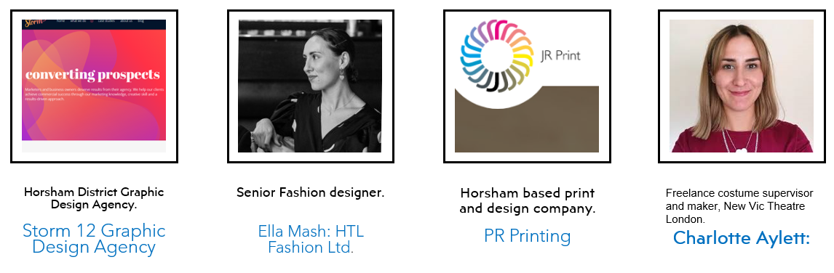 | What are the key messages employers have told us in the visual arts?  - RESEARCH: Strong, advanced research skills with genuine curiosity for the industry itself.  - COLLABORATION: The ability to openly collaborate , have good communication skills both verbally & digitally.  - PRACTICAL SKILLS: Strong prior learning in basic art & design skills but a willingness to adapt & learn new industry specific skills.  How do we promote these skills & values in our subject?  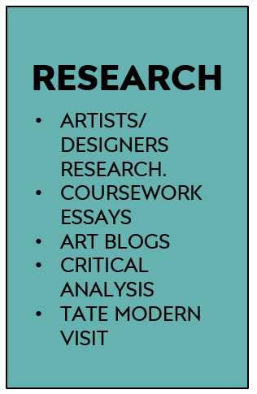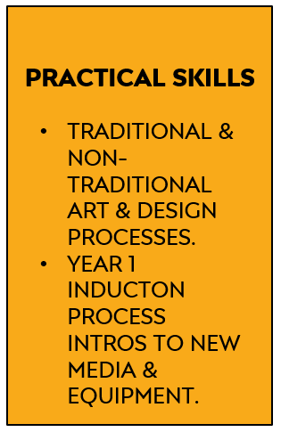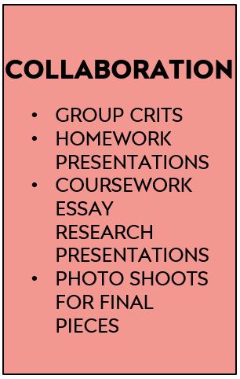  ERB 1 ERB 2 ERB 3
What do the Progress Review sections mean on this course?
- Progress Reviews in the A Level Art Department: for the purposes of self-assessment and teacher assessment, progress reviews are divided into:
- Performance grades: Performance Grades - A*-E for A Levels Year 2. Target (expected grade based on prior GCSEs). Current (grade you are currently working at. Estimated (an estimate of the grade you should realistically be able to achieve at the end of the course).
- Studentship grades: Studentship Grades - 1= outstanding, 2= good, 3= requires improvement, 4= serious cause for concern.
- Effort (commitment to study) - Hours per week of independent study per subject including:Teacher directed study – blog, life-drawing, homework tasks, coursework. Student directed study – consolidating learning, research or reading, skills practice, taking extra first-hand photos.
- Systems (organisation of study) Time Management - punctuality, completing planned study, completing homeworks, meeting deadlines. Organisation - bringing relevant equipment, sketchbooks, organisation of annotations, having work printed-out/presented on time.
- Practice (study behaviours) In class – full participation in lessons e.g. engaged listening, asking questions, contributing to discussion, using practical time well. Independent Study – practising skills as well as consolidating knowledge, , use of subject VLE, Pinterest, artists/designers blogs, visiting exhibitions & museums. Taking responsibility for learning – addressing problems, seeking help, using feedback constructively, attending subject workshops, identifying and avoiding distractions/barriers to learning.
- Attendance: Attendance - Percentage of classes attended in period. Punctuality - Percentage of classes attended on time in period.

How can I improve my progress in this subject?  A Level studentship can be easily improved by paying attention to the following points across all endorsements:  - Excellent attendance and punctuality; vital in practical subjects.  - Careful reading of this course’s Share Point each week to be clear of weekly tasks and use given resources to guide your work.  - If you miss a lesson for a valid reason; check Share Point to be prepared for the next lesson you attend; read the set work and watch any Power Points, videos used in class.  - Book-craft is very important:it includes quality titles, layout, annotation of work.  - Considered choices of artists and strong personal responses. |  | - Thoughtful Rod Taylor analysis of work using specialist vocabulary, see glossary on Share Point.  - Strong artists research from multiple sources.  - Handing all work in on time to allow for adequate verbal feedback and participate meaningfully in group crits of homeworks and final pieces.  - Act upon your feedback from your teacher.  - Attending workshops when you need extra 1-1 help on class or homeworks.
What methods do we use for assessment on the course?  Examples of some formative assessment methods we use every day in the Art Department:  - Establishing success criteria for the lesson, task, homework or section of coursework.  - Use of targeted closed questions exploring levels of understanding  - Use of open questioning to extend learning  - Self assessment/reflection  - Peer assessment  - Use of response partners/ small group  - Use of mini-plenaries during the lesson. |  | Examples of summative assessments we also use at specific times of the academic year:  - A final artifact for coursework - a print, drawing, painting, garment, textiles piece, digital piece.  - Year 2 exam sketchbook  - Year 2 exam 15 hour final exam piece.  - Year 1 Transfer Exam submission.  - A final essay – the 1000 word coursework essay.  - A component submission - the coursework or the exam unit.
What feedback do we use on the course?  Critiques (crits)  - Group homework crits each week or at key homework points.  - Lots of different formats from individually showing work to laying books in table for discussion.  - Final piece crits at the end of a final piece.  Use of Exemplar work in the class-room:  - Group discussion of excellent homeworks for inspiration.  - Group discussions of excellent processes, eg printmaking, dye samples etc.  - Share Point exemplar Power Points.  - Pinterest examples on Susie’s site. |  | Others:  - 1-1s with staff formally & informally in class.  - Post-it notes in sketchbooks for improvement suggestions.  - Teams feedback for Graphics.  - Year 1 Transfer Feedback sheet with actions.
How does the work support the Collyers Policy on British Values?  - The selection of artists, designers and makers complies and acknowledges the precepts identified by the  college clearly in both Pro Study and the core curriculum; Democracy,The rule of Law,Individual liberty,  Mutual Respect,Tolerance of different faiths and beliefs. |  | 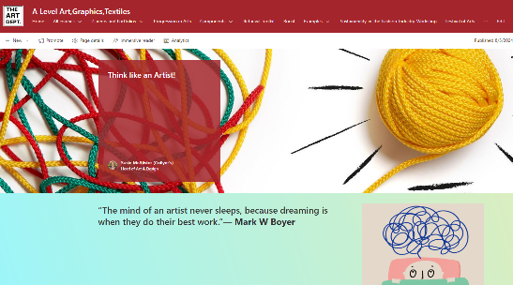  It is an essential part of your growth as an artist to understand what factors can drive individual creativity,  see the Think Like an Artist section on Share Point.

